Family Support Agencies and Organisations
Please find below a list of agencies that remain available during the Summer break to support families.
Organisation | Who They Are and What They Say | Contact Details
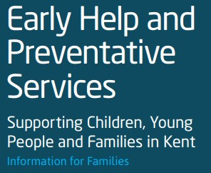 | We provide services that can be accessed at a time and place that suits families to help them to do well, stay safe and resolve problems at the earliest possible opportunity, before they become more serious. | https://www.kent.gov.uk/socialcare-and-health/care-andsupport/early-help-support-forfamilies
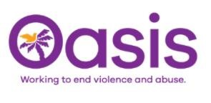 | We provide support across a range of needs and risks for those affected by domestic violence to ensure families get the support they need. | http://www.oasisdaservice.org/ raise
 | We offer free support with mental health and wellbeing for people in Kent. You might be struggling with anxiety or depression, experiencing stress, feeling hopeless, isolated or overwhelmed.  We are here to listen to you. | https://www.porchlight.org.uk/infor mation-support/list-of-supportservices
Kent Young Carers   | The countywide service for Young Carers aged 5-18 across Kent.  Young Carers are taking on caring responsibilities for a family member with a long-term illness, disability, mental health or substance misuse issue. | https://www.imago.community/Chil dren-and-Young-People/KentYoung-Carers
CYPMHS (CAMHS) – NHS  Mental Health Support  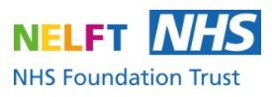 | YPMHS stands for the Children and  Young People's Mental Health Service. Kent CYPMHS provides emotional wellbeing and mental health advice and support for young people and families across Kent  If you are in Crisis or require out of hours support please call SPA, 24 hours a day, on 0800 011 3474. We will listen and talk through the support available to you and your child. | https://www.nelft.nhs.uk/kentcypmhs-get-in-touch
 | Available for all young people, whatever the problem. | https://www.childline.org.uk/  0800 11 11
 | We want to see a world where no young person feels alone with their mental health, and all young people get the support they need, when they need it, no matter what. | https://youngminds.org.uk/findhelp/looking-after-yourself/
 | Your online mental wellbeing community  Free, safe and anonymous support | https://www.kooth.com/
 | We’re an online service providing access to millions with anxiety, depression and other common mental health issues. | https://togetherall.com/en-gb/ourwork/
  Social Services | If you think you have any care and support needs, you can contact us to ask for a free assessment. | https://www.kent.gov.uk/socialcare-and-health/care-andsupport/how-to-get-help#tab-1
We are With You   | Addaction, Young Addaction and Thinkaction have changed their names to We Are With You.  We Are With You provides free, confidential support to people who have issues with drugs, alcohol or mental health. | https://www.wearewithyou.org.uk/
 | Cruse Bereavement Care is the lead national charity providing bereavement support services. We offer support, advice and information to children, young people and adults when someone dies.  Cruse offers face-to-face, telephone, email and website support. | https://www.cruse.org.uk/gethelp/local-services/southeast/south-kent
Kent Resilience Hub  (Moodspark)   | Supporting 10-16 year olds to cope better with the pressures of everyday life.  A place where young people aged 10-16 can learn how to look after their emotional and mental health and find ways to help them bounce back when life gets tough | https://moodspark.org.uk/
 | A directory of support including out of hours mental health support. | https://livewellkent.org.uk/in-yourarea/south-kent-coast/
 | Fearless is a service that allows you to pass on information about crime 100% anonymously. This means you don't have to give us any personal details. | https://www.fearless.org/
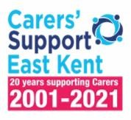 | Welcome to Carers’ Support East Kent, a charity that provides Carers with the information and support they need.  Who we help:  You may not think of yourself as a Carer, but our services are available to you if you look after a relative or friend, who due to physical or mental illness, agerelated difficulties, disability or an addiction, cannot manage without your support. | https://carersek.org.uk/  0300 302 0061
Meetoo  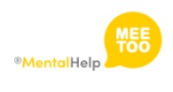 | MeeToo is an award winning, free, anonymous app where young people can talk about difficult things. MeeToo provides a safe, pre-moderated (by humans) space for young people aged 11+ to experiment with opening up about whatever may be on their mind.  MeeToo supports over 6,000 young people each month. | https://www.meetoo.help/howmeetoo-works
Police 101   | 101 is the non-emergency contact number for any police force in England and Wales and it is available 24 hours a day, 7 days a week | 101
NHS 111   | NHS 111 can help if you have an urgent medical problem and you’re not sure what to do. | 111 https://www.nhs.uk/nhsservices/urgent-and-emergencycare-services/when-to-use-111/

