PE Funding

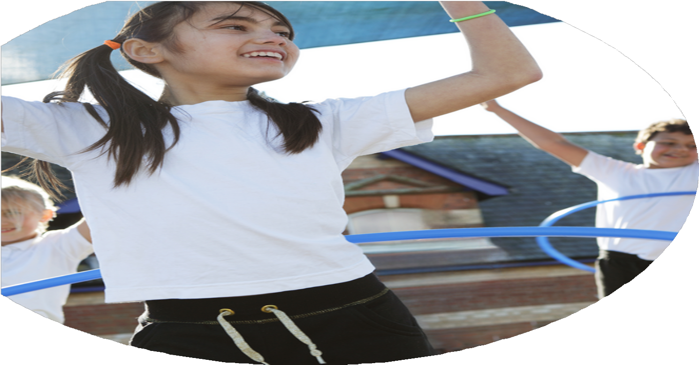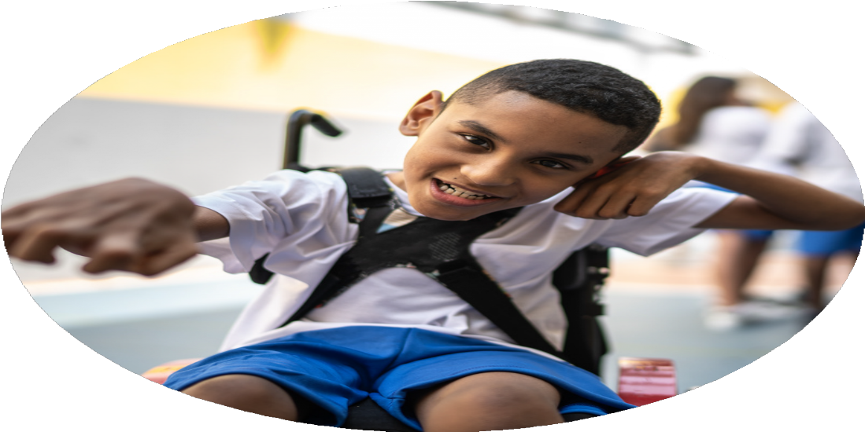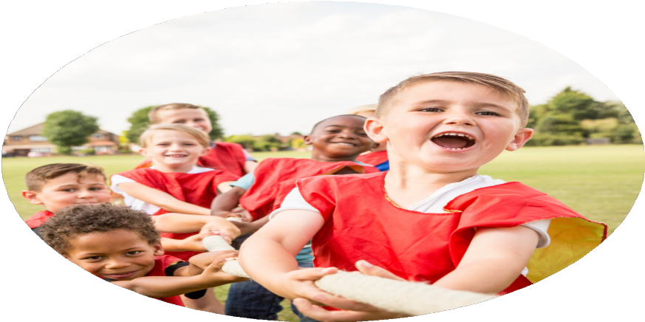

Evaluation Form

**Commissioned by**

**Created by**

Images courtesy of Youth Sport Trust

**PE Funding Evaluation Form**

 It is intended that this template should be used as preparation for the completion of the statutory digital reporting tool being introduced this academic year. You can upload data (including swimming) from this template onto this platform once it becomes accessible.

 Before you decide how you are going to use the funding for this academic year you should reflect and evaluate the impact of your use of the funding in 2023/24.

 All spending of the funding must conform with the terms outlined in the Conditions of Grant document.  The template is a working document that you can amend/update during the year.

 Based on your evaluation of last year’s funding you should decide what you intend to do this academic year, how you will do it, and what impact you expect it to have.

It is important that the funding is used effectively and based on your school’s needs.

 You must use the funding to make additional and sustainable improvements to the PE and sport in your school.  You must develop and add to the PESSPA activities that your school already offers.

*Summative digital reporting from June 2025 will continue to include swimming and water safety information therefore funding can be used to provide top-up lessons where necessary to ensure pupils meet national curriculum swimming requirements.*

Changes to zone areas and adult support

Data collected shows lower participation levels than we would like as a school

No opportunity to timetable Yoga for year 6 pupils

We are consistently reflecting and reviewing this new venture.

It was a very enjoyable and exciting day for all of the pupils, thoroughly enjoyable for all

The opportunity for a greater percentage of pupils to in lower KS2 and KS1 to represent the school at inter school competitions

The opportunity to offer curriculum Yoga to our year 6 cohort.

All pupils are physically active for 60mins daily. All pupils engaged in ‘Play’ risk/benefit taking and being physically active.

All pupils experienced Yo Street Football

Skateboarding training with Scorcha Skate

All year 6 pupils were offered the opportunity to represent the school at inter school competitions. 98% accepted, competing at different levels of competition.

60% of year 5 pupils were offered the opportunity to represent the school at inter school competitions. 60% accepted, competing at different levels of competition.

50% of year 2,3 and 4 pupils were offered the opportunity to represent the school at inter school competitions. 60% accepted, competing at different levels of competition. 50% accepted, competing at different levels of competition.

100% of pupils EYFS to year 5 accessed Yoga for 2 terms on a weekly basis.

The introduction of OPAL play times for all pupils

The opportunity for new sporting

experiences

The opportunity for a high percentage of children to access competitive sport

Continued curriculum Yoga opportunities for all of our pupils provided by outside Yoga teacher.

What are your plans for 2024/25?

Intent

How are you going to action and achieve these plans?

Implementation

1. Quality of teaching and learning in Physical Education will be developed through bespoke staff training and support for all teachers and support staff, including PE subject leaders.

Support by SL for all class teachers with planning, progression and assessment

PE resources updated to enable HQ teaching to take place

1. OPAL team to work to continue to develop all pupils to be physically active on average 60mins daily at break and lunchtime

Continue to develop OPAL opportunities at break and lunchtimes to engage all pupils to be physically active on a daily basis

Equipment and resources to be purchased to facilitate all pupils to access independent play

Increase the number and range of activities and clubs on offer aligned to pupil voice.

Implementation of new extra-curricular timetable

1. SL to research new sporting experience days for whole school. SL to plan and deliver opportunities for all pupils
2. SL to research outside provider to provide support and CPD required to introduce new sport Pickleball.
3. SL to work with local schools to offer multi-skills competition for KS1 pupils

All UKS2 pupils offered opportunity to represent school through School Games Format competitions and competitions organized by local schools.

SL to track pupils involvement ensuring all KS2 pupils offered access to competitive opportunities.

**Aims and Objectives**

1. To ensure all children are participating in two hours a week high quality PE by continuing to focus on teacher and support staff training ensuring all teachers and support staff are confident to enjoy teaching and supporting High Quality Physical Education
2. Continue on our OPAL journey to ensure that all pupils are physically active on average 60mins daily.

To include tracking, attendance and engagement of after school activities for groups of children eg PP, disadvantaged children to increase physical activity

1. To offer all pupils broad and engaging sporting opportunities through whole school new experience days.
2. To implement new sporting experiences within the curriculum of new and different sports such as Pickleball
3. Ensure all pupils can access competition in school through termly intra-sport school competitions as well as all KS2 pupils access inter-school competition. Competition formats to reflect needs of pupils. See School Games offer. KS1 children to be included in offer wherever opportunity presents.

What impact/intended impact/sustainability are you

expecting?

How will you know? What **evidence** do you have or

expect to have?

1. Survey from staff to establish CPD need. Evaluation form following CPD opportunity from all staff. High quality teaching and learning within all PE and Games lessons. Lesson observations
2. Action plan from OPAL team. Pupil voice feedback
3. Pupil voice feedback.
4. Pupil voice feedback. Feedback from teaching and support staff.
5. Tracking sheet completed by SL. Evidence of all competitions entered and results on website
6. The impact will be all teaching and support staff will have increased knowledge and confidence within PE and Games. Sustainability will be that all teaching and support staff will continue to develop their knowledge and confidence with support from PE subject Leader and outside providers.
7. Intended impact all pupils to be physically active. To understand their right to ‘Play’. To develop positive relationships, to learn how to take risks and problem solve.
8. By introducing a new and different sporting experiences may engage pupils to make links with local sports club to continue as a lifelong sporting opportunity.
9. The impact intended is that pupils will be physically active and the new experience maybe their lifelong sporting activity.
10. The impact will be a high percentage of KS2 pupils will represent the school at inter-sport. Sustainability will be SL to track and ensure all pupils receive the opportunity to participate at a competitive level pupil are comfortable with.

What **impact/sustainability** have you seen?

What **evidence** do you have?