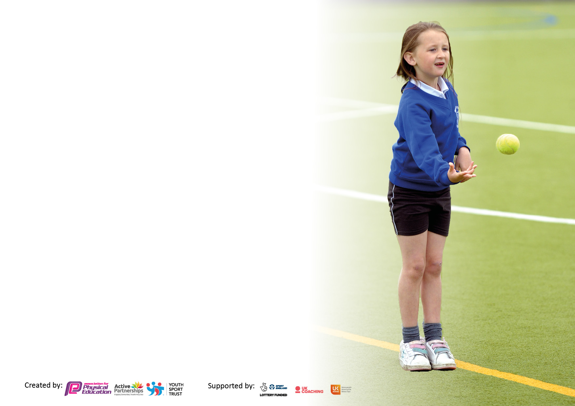

It is important that your grant is used effectively and based on school need. The [Education Inspection Framework](https://www.gov.uk/government/publications/education-inspection-framework) makes clear there will be a focus on **‘whether leaders and those responsible for governors all understand their respective roles and perform these in a way that enhances the effectiveness of the school’**.

Under the Quality of Education judgement, Ofsted inspectors consider:

**Intent** - Curriculum design, coverage and appropriateness

**Implementation** - Curriculum delivery, teaching (pedagogy) and assessment

**Impact** - Attainment and progress

To assist schools with common transferable language, this template has been developed to utilise the same three headings which should make your plans easily transferable between working documents.

Schools must use the funding to make additional and sustainable improvements to the quality of Physical Education, School Sport and Physical Activity (PESSPA) they offer. This means that you should use the Primary PE and sport premium to:

* Develop or add to the PESSPA activities that your school already offers
* Build capacity and capability within the school to ensure that improvements made now will benefit pupils joining the school in future years
* The Primary PE and sport premium should not be used to fund capital spend projects; the school’s budget should fund these.

Please visit <https://www.gov.uk/guidance/pe-and-sport-premium-for-primary-schools> for the revised DfE guidance, including the 5 key indicators across which schools should demonstrate an improvement. This document will help you to review your provision and to report your spend. DfE encourages schools to use this template as an effective way of meeting the reporting requirements of the Primary PE and Sport Premium.

We recommend you start by reflecting on the impact of current provision and reviewing the previous spend.

Schools are required to publish details of how they spend this funding, including any underspend from 2021/2022, as well as on the impact it has on pupils’ PE and sport participation and attainment.

We recommend regularly updating the table and publishing it on your website throughout the year. This evidences your ongoing self-evaluation of how you are using the funding to secure maximum, sustainable impact. Final copy must be posted on your website by the end of the academic year and no later than the 31 July 2023.

**Details with regard to funding**

Please complete the table below.

|  |  |
| --- | --- |
| Total amount carried over from 2021/22 | £00000 |
| Total amount allocated for 2022/23 | £19560 |
| How much (if any) do you intend to carry over from this total fund into 2023/24? | £7951 *(of which £2500 is allocated)* |
| Total amount of funding for 2022/23 to be reported on by 31st July 2023 | £ 14109 |

**Swimming Data**

Please report on your Swimming Data below.

|  |  |
| --- | --- |
| Meeting national curriculum requirements for swimming and water safety.  **N.B.** Complete this section as best you can. For example, you might have practised safe self-rescue techniques on dry land which you can then transfer to the pool when school swimming restarts.  **Due to exceptional circumstances priority should be given to ensuring that pupils can perform safe self-rescue even if they do not fully meet the first two requirements of the NC programme of study** |  |
| What percentage of your current Year 6 cohort swim competently, confidently and proficiently over a distance of at least 25 metres?  **N.B.** Even though your pupils may swim in another year, please report on their attainment on leaving primary school at the end of the summer term 2023.  Please see note above | 93.5% |
| What percentage of your current Year 6 cohort use a range of strokes effectively [for example, front crawl, backstroke and breaststroke]?  Please see note above | 93.5% |
| What percentage of your current Year 6 cohort perform safe self-rescue in different water-based situations? | 93.5% |
| Schools can choose to use the Primary PE and sport premium to provide additional provision for swimming, but this must be for activity **over and above** the national curriculum requirements. Have you used it in this way? | Yes |

**Action Plan and Budget Tracking**

Capture your intended annual spend against the 5 key indicators. Clarify the success criteria and evidence of impact that you intend to measure to evaluate for pupils today and for the future.

|  |  |  |  |  |
| --- | --- | --- | --- | --- |
| **Academic Year:** 2022/23 **River Primary School** | **Total fund allocated: £19560** | **Date Updated: September 22, February 23 July 23** | |  |
| **Key indicator 1:** Increase confidence, knowledge and skills of all staff in teaching PE and sport | | | | Percentage of total allocation: |
| % |
| **Intent** | **Implementation** | | **Impact** |  |
| Your school focus should be clear on what you want the pupils to know and be able to do. What do they need to learn and to consolidate through practice: | Make sure your actions to achieve are linked to your intentions: | Funding allocated: **£5460**  **Actual spend £5125** | Evidence of impact:  What do pupils now know and what can they now do? What has changed? | Sustainability and suggested next steps: |
| To upskill both teaching and support staff across the whole school within PE and Games  To support confidence and subject knowledge for all teaching and support staff.  To supporting teaching staff to structure and deliver high quality teaching and learning for all pupils across dance, gym and games | SL to compile whole staff PE CPD survey  All staff to complete PE CPD survey  SL to analyse survey and plan a 2-year CPD schedule for all staff  SL to share with SLT and all staff  CPD opportunities to begin from T3  SL to support CTs to plan and deliver x6 weeks of dance, gym or games using a supportive role | £4500 cover for SL to complete whole staff CPD plan | T3 – T6 15 CT and 19 TA’s have completed 6 weeks of CPD from SL. All staff now confident to use TGKU when teaching Gym, Dance and Athletics. | SL to continue to support where required CPD for all staff. To continue to develop all CT and TA’s confidence and knowledge when teaching Gym, Dance and Athletics. |
| To engage year 4 and year 6 staff and children in Chance to Shine Cricket programme | Liaise with KCCC  SL to meet with KCCC coach  KCCC coach to deliver 6 weeks of weekly cricket coaching for pupils and staff | N/A | 120 pupils completed programme. All cricket skills and values developed.  CPD opportunity for 10 members of staff.  Leadership opportunity for 10 year 5 pupils to lead and deliver cricket skills within active play sessions. | SL to continue to work with KCCC to continue to deliver Chance to Shine cricket programme in next academic year. |
| All teaching and support staff to attend Yoga sessions delivered by outside provider  All staff to use CPD opportunity from these sessions  All staff to use calming techniques taken from sessions when required by pupils  Continue YST membership to ensure access for a range of resources for learning, CPD opportunities for staff. To access current PE and Sport information and guidelines | SL to research and book outside provider within Yoga  SL to complete timetable for whole school to access sessions throughout academic year  Business manager to renew YTS membership  SL to share resources with staff to support pupils to be physically active | Please see KI 4  £200 | 12 CT and 15 TA’s have attended Yoga sessions provider by qualified Yoga outside provider.  All staff more confident to use calming techniques when required by pupils.  SL kept up to date with latest initiatives to ensure all pupils are being as physically active within the latest government guidelines.  To use cross-curricular resources to support reading. | Yoga sessions booked for academic year 2023/24.  Renewed membership for academic year 2023/24. |
| To purchase AFPE membership to allow up to date information for all aspects within PESSPA.  SL to access current up to date information  SL to attend webinars to develop own CPD | Business manager and SL to sign up to AFPE  SL to use AFPE website on regular basis | £180 | SL kept up to date with latest initiatives to ensure all pupils are being as physically active within the latest government guidelines.  SL to complete webinars to ensure school is working in line with latest evidence and guidance, | Renewed membership for academic year 2023/24. |
| Purchase Safe Practice book rom AFPE website to ensure all current health and safety requirements in PESSPA are adhered to. | Business manager to purchase book  SL to share with all members of staff | £45 | SL and SLT aware of guidelines and up to date safe practice within all areas of PE and School Sport. | Replace with next edition when required. |
| SL to attend annual PE Conference to keep up to date with latest good practice within PE and School Sport. | Business manager to book conference  SL to attend | £200 fee including 1/2day supply cover | SL know aware of latest government guidelines. Attended workshop for Deep Dive in PE. SL now more confident to present PE and Games should we receive Deep Dive into PE and Games. | SL will continue to attend annual PE conference to keep up to date with latest information and guidelines. |
| **Key indicator 2:** The engagement of all pupils in regular physical activity – Chief Medical Officers’ guidelines recommend that  primary school pupils undertake at least 30 minutes of physical activity a day in school | | | | Percentage of total allocation: |
| % |
| **Intent** | **Implementation** | | **Impact** |  |
| Your school focus should be clear on what you want the pupils to know and be able to do. What do they need to learn and to consolidate through practice: | Make sure your actions to achieve are linked to your intentions: | Funding allocated:  **£6500**  **Actual spend £2183** | Evidence of impact:  What do pupils now know and what can they now do? What has changed? | Sustainability and suggested next steps: |
| Provide Active Play opportunities for all pupils to access regular daily physical activity | Active Play equipment to enhance provision provided.  Active Play to have zoned areas for participation in different activities  Pupil voice used to structure the games offered  Support staff to lead and engage with all pupils  SL and SLT to oversee provision is offered daily | £ Estimated £800  £642 equipment | All pupils are physical active for 45mins daily through structured adult led games activities. | SL to continue to provide timetables for staff and timetables of activities available for pupils for academic year 2023/4. This will be done through the use of pupil voice. |
| All equipment required to deliver PE and Games within the curriculum.  Ensure continued level of engagement of all pupils. | SL to purchase new equipment, to enhance the range of sports on offer to all pupils. | Estimated £500  Apple music dance  £120  Equipment running total  £535 | All pupils have access to a broad curriculum within Gym, Dance and Games. All pupils deepen their knowledge and understanding of being physically active and what a healthy active lifestyle is. | SL to continue to research new and exciting opportunities for all pupils to encourage a love of sport and the benefits of a physical active lifestyle. |
| Additional focus swimming for pupils in year 4,5 and 6 to support 100% of year 6 pupils swimming 25m. | SL to identify focus pupils to attend  Book swimming sessions with Safely Swim  Office staff to book transport | £504 swimming sessions  Transport £382 | 11 of 12 pupils can now swim 25m and perform self  save rescue. | SL to swimming teacher will identify 14 pupils from KS2 to attend 6 additional swimming sessions in academic year 2023/24 |
| Extend existing Timber Trial to extend physical active for all pupils. To develop risk taking and own risk assessment for all pupils | BM and HoS to research equipment  BM to order equipment | Estimated £2500  To be carried over to 2023/24 | All pupils will have access to enhanced Timber Trial. This will encourage all pupils to be physically active for 60 minutes daily. | HoS and BM to ensure that Timber Trial is installed in academic year 2023/24. |

|  |  |  |  |  |
| --- | --- | --- | --- | --- |
| **Key indicator 3:** The profile of PE and sport is raised across the school as a tool for whole school improvement | | | | Percentage of total allocation: |
| % |
| **Intent** | **Implementation** | | **Impact** |  |
| Your school focus should be clear on what you want the pupils to know and be able to do. What do they need to learn and to consolidate through practice: | Make sure your actions to achieve are linked to your intentions: | Funding allocated:  **£3000**  **Actual spend £2524** | Evidence of impact:  What do pupils now know and what can they now do? What has  changed? | Sustainability and suggested next steps: |
| All pupils year 2 and above to access active learning through Cross Curricular Orienteering x3 15mins weekly sessions  Pay annual Cross Curricular Orienteering subscription fee for new and additional resources for all pupils within school  Increase cross-curricular links with PE  Increased time for pupils to be physically active | Access school portal for support and learning resources  Year 2 and KS2 teachers to share maps and learning resources created on a weekly basis  Business manager to pay annual subscription fee | £480 annual fee | All pupils from year 1-6 have completed learning within games and ready to access cross-curricular orienteering. Pupils able to use map reading skills to be able to complete learning in a more active way. | All CT’s to offer active learning at least 3 times a week within cross-curricular learning.  SL to lead CPD session in T1. |
| All pupils to participate in National Sport week 19th – 25th June 2023  To provide all pupils with Orienteering competition with live leader board updates to promote competition using school values | Select focus for cross curricular learning opportunities - **Do we have more in common than not?**  SL to discuss focus with HoS  SL to share ideas in staff meeting  Staff to plan for Diversity Sport week  SL to register with YST National Sports Week  Rainbow Laces Day  SL to research and book opportunity for all pupils  SL to produce timetable for day  Whole day provided by outside providers | Estimated £200  £57.56 Books  £248 mosaic tiles  Yr 4 £28.54  Dover Pride £120  £268  £1322.25 | All pupils, CT and TA’s engaged in Diversity/Sports week. Pupils now have a better understanding of Protected Characteristics, diversity within sport and considered the question Do we have more in common than not?  All pupils took part in day, using their own level of personal challenge and fitness to complete the challenge. | School will participate within National Sports Week with a new focus for next academic year.  SL to continue to monitor new and exciting challenges to encourage a love of being physically active. |
| **Key indicator 4:** Broader experience of a range of sports and physical activities offered to all pupils | | | | Percentage of total allocation: |
|  |
| **Intent** | **Implementation** | | **Impact** |  |
| Your school focus should be clear on what you want the pupils to know and be able to do. What do they need to learn and to consolidate through practice: | Make sure your actions to achieve are linked to your intentions: | Funding allocated:  **£3400**  **Actual spend £3100** | Evidence of impact:  What do pupils now know and what can they now do? What has  changed? | Sustainability and suggested next steps: |
| All pupils to attend Yoga sessions throughout academic year from an outside provider  Pupils will learn and consolidate how Yoga can support mental health and well being | SL to research and book outside provider within Yoga  SL to complete timetable for whole school to access sessions throughout academic year | £1920 | All pupils have experience Yoga as a way to be active, a way to relax and improve mental health and well-being. To improve body strength, balance and flexibility. | Yoga sessions booked for academic year 2023/24. |
| To keep of all-weather surface in good condition, ensuring all pupils can access physical active throughout the whole school year | Business manager to arrange with company that installed all weather surface to provide annual service and up keep. | £590 | All pupils able to access outdoor learning and be physically active throughout the whole school year. All pupils are able to enhance performance when competing on sport surface. | All weather surface to be looked after and kept in good condition for continued all year round access for all pupils. |
| To introduce the new sport of Squash for all year 3 pupils. All pupils will have a better understanding of Squash. Outside provider to provide opportunity for all pupils with links to local Squash club following the 6 weekly sessions. | SL to liaise with local Squash Club  SL and outside provider to arrange dates, delivery and learning for all pupils  Outside provider to offer x6 weekly sessions for all year 3 pupils | £450 | 60 pupils have experienced basic squash skills. Pupils have a better understanding of the skills required for squash and have access to make links with local junior squash club. | SL to research squash coach returning in academic year 2023/24. |
| To offer After School Gardening Club to all pupils on sign up basis  To engage pupils in healthy active lifestyle choice  To encourage pupils to be physically active on a regular basis | SL to compile letter to parents  Pupils to sin up to club  Club overseen by KJ with support from SL | Estimated £500  Katy/Heidi/Amy overtime gardening club  T1 and T2 £140 | 40 pupils attended club and have grown a varied of vegetables. Pupils have developed a love for gardening and now understand where food comes from. | Gardening club will be offered as an extra-curricular club for next academic year. |

|  |  |  |  |  |
| --- | --- | --- | --- | --- |
| **Key indicator 5:** Increased participation in competitive sport | | | | Percentage of total allocation: |
| % |
| **Intent** | **Implementation** | | **Impact** |  |
| Your school focus should be clear on what you want the pupils to know and be able to do. What do they need to learn and to consolidate through practice: | Make sure your actions to achieve are linked to your intentions: | Funding allocated:  **£1200**  **Actual spend**  **£1177** | Evidence of impact:  What do pupils now know and what can they now do? What has  changed? | Sustainability and suggested next steps: |
| Offer level 2 competitions to a large percentage of pupils across whole school  To use current School Games criteria to select pupils to attend events | SL to attend DSG meeting  SL to track all children attending events  SL to follow School Games criteria to select appropriate children for events | N/A | Pupils confidence increased and experience of participating in competitive sport. | Pupils will be entered into all DSG competitions and additional opportunities when arising. |
| Dover School Games Buy in competition package. To offer pupils higher level of competitive competition | SL to attend DSG meeting  SL to follow School Games criteria to select appropriate children for events | £300 | Pupils participated in all 6 competitions offered with a number of notable results for some pupils. | SL to buy into competitive package for next academic year to ensure a higher level of competition for more abled pupils within sport. |
| To enter boys and girls football league and cup competitions | SL to enter and boy and girls football league and cup competitions  SL to arrange all matches | £35 league fees  £65 balls and captains armbands | 16 boys and 10 girls represent the school in football cup, league and tournaments. Teamwork, respect and sportsmanship skills developed by all 26 pupils. Boys won 3 cup competitions and league winners.  Girls reached quarter-finals of cup competition and finished runners-up in their league. | Boys and Girls football teams will compete in local league and cup competitions next academic year. |
| All pupils to participate in termly Intra-sport competitive competitions | SL and pupils to plan termly intra-sport competitive competitions for all Key Stage 1 and 2 pupils  EYFS pupils to participate from term 6  SL to work with Sports Ambassadors to officiate within a number of different fundamental events (KS1) and sports (KS2) | Estimated £100 | All pupils have a better understanding of competitive sport. All KS2 pupils have experienced leadership and officiating roles within sport. | Fill programme of intra-sport opportunities will be completed across every term for all pupils. |
| All pupils across the whole school to participate in competitive sports day | SL to plan and deliver sports days for whole school  Sports Ambassadors to support SL | Estimated £100  £48 Medals | All pupils participated in competitive sport, developing and understanding of how to be a good sportsman. Leadership opportunities for 62 year 6 and 30 year 4 pupils to support and lead sports day. | Sports days booked for next year. |
| Transport when required to be booked to enable pupils to attend competitive competitions | SL and office staff to research and book all transport required | Estimated £600  £435 Mini bus for county finals  £99 Sportshall Athletics  £195 Polo Farm | Pupils offered the opportunity to compete at level 2 events. Understanding the next level of competition, of working within a team and demonstrating sportsmanship and respect when representing the school. | Level 2 sports opportunities will continue to be offered to a high percentage of pupils across the school year. |

|  |  |
| --- | --- |
| Signed off by | |
| Head Teacher: |  |
| Date: |  |
| Subject Leader: |  |
| Date: |  |
| Governor: |  |
| Date: |  |