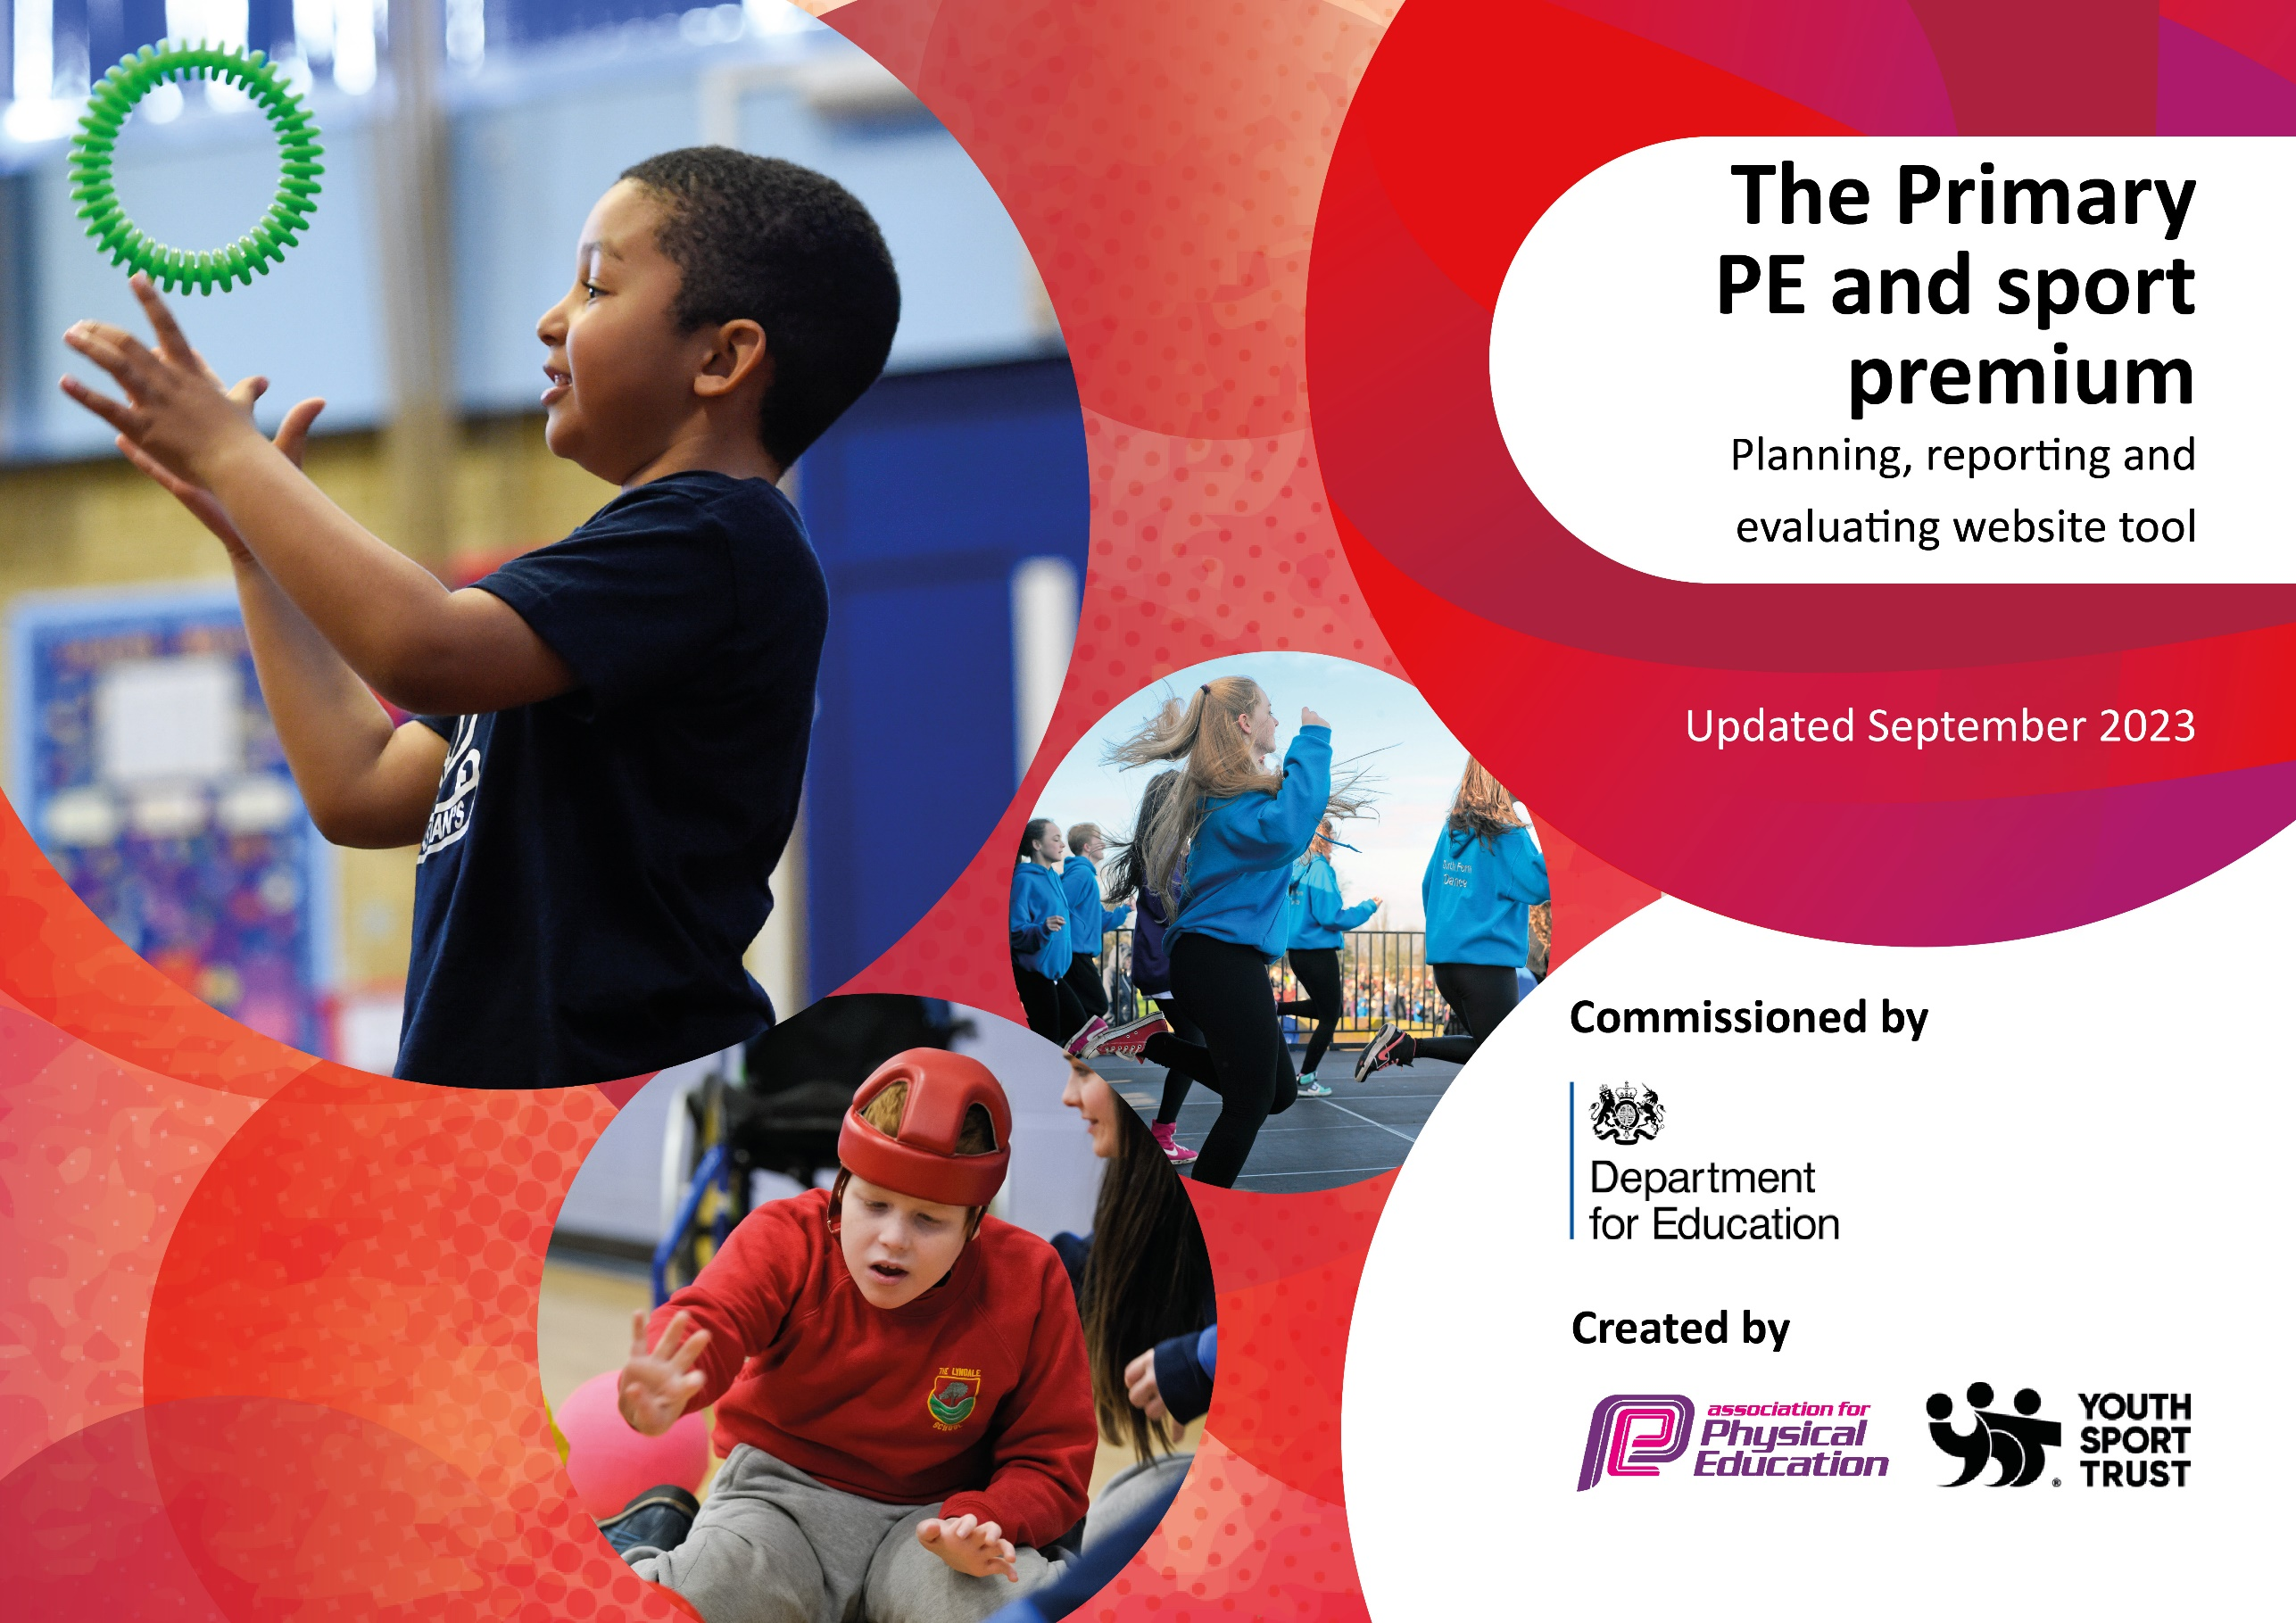

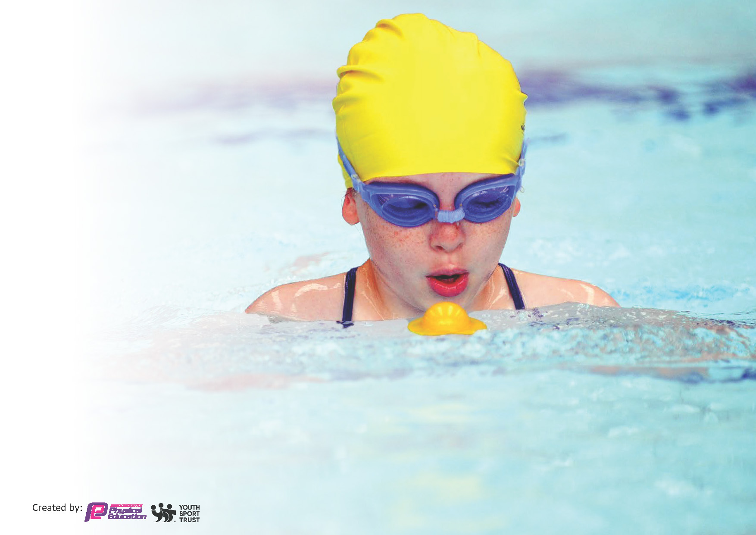
This template can be used for multiple purposes:
by:
- It enables schools to effectively plan their use of the Primary PE and sport premium
- It helps schools to meet the requirements (as set out in guidance) to publish information on their Primary PE and sport premium
- It will be an effective document to support Ofsted inspections enabling schools to evidence progress in Physical Education (PE) and evidence swimming attainment, which forms part of the PE National Curriculum. We would recommend schools consider
the Intent, Implementation and Impact of any spend, as examined within the Education Inspection Framework.

It is important that your grant is used effectively and based on school need.

Schools must use the funding to make additional and sustainable
improvements to the quality of the PE, School Sport and Physical Activity (PESSPA)
they offer. This means that you should use the Primary PE and sport premium to:

- Build capacity and capability within the school to ensure that improvements made now will benefit pupils joining the school in future years
- Develop or add to the PESSPA activities that your school already offers.

The Primary PE and sport premium should not be used to fund capital spend projects; the school’s core budget should fund these. Further detail on capital expenditure can be found in the updated Primary PE and sport premium guidance.

The Primary PE and sport premium guidance, outlines 5 key priorities that funding should be used towards. It is not

necessary that spending has to meet all the key priorities, you should select the priorities that you aim to use any funding towards.

Although completing this template is not a requirement for schools, schools are required to publish details of how they spend this funding. Schools must also outline what the impact this funding has had on pupils’ PE and sport participation and attainment and how any spending will be sustainable in the future. All funding must be spent by 31st July 2024.

The Department for Education has worked closely with the Association for Physical Education (afPE) and the Youth Sport Trust (YST) to develop this template and encourages schools to use it. This template is an effective way of meeting the reporting requirements of the Primary PE and sport premium.
Total amount allocated for 2023/24 | £19560
How much (if any) do you intend to carry over from this total fund into 2023/24? | £7951 (of which £2500 is allocated)
Total amount to be spent 2023/24 | £27511

Review of last year’s spend and key achievements (2022/2023)

We recommend you start by reflecting on the impact of current provision and reviewing your previous spend.

Activity/Action | Impact | Comments
Main achievements  On reflection from last years spend, the action that had the biggest impact was the CPD opportunity given to all teaching and support staff. All staff worked with PE Subject Leader for at least one term in gymnastics or dance. | All teaching and support staff have developed and improved their practice within gymnastics or dance. All staff have a better understanding of TGFKU. Teaching and learning for all pupils has been engaging with progression planned for. | An ongoing cycle of CPD for all staff within all areas of PE and Games will continue into academic year 2023/24.
The introduction of Yoga within the curriculum, as a after school club and a lunchtime club for our pupil premium pupils delivered by an outside provider as impacted on a high number of pupils mental health and well-being. | All pupils from EYFS to year 5 participate within the curriculum in 4 sessions over two terms. Pupils have a better understanding of calming techniques t o support themselves when required. All teaching and support staff attending sessions, taking techniques and strategies back to the classroom. | Continuous programme of Yoga sessions and clubs booked for 2013/24.
Continued competitive opportunities for all pupils are actively researched and attended.  The enthesis on a healthy actively lifestyle remains a driving force within our school. | All pupils access competitive sport on a termly basis as will as higher levels of competition for a large number of our KS2 pupils. Active play, active learning and active after school clubs all contribute to our ethos of a lifelong active healthy lifestyle. | All opportunities will remain as will as research and engagement will continue to progress, offering more pupils active and competitive opportunities.

Key priorities and Planning
This planning template will allow schools to accurately plan their spending.

Action – what are you planning to do | Who does this action impact? | Key indicator to meet | Impacts and how sustainability will be achieved? | Cost linked to the action  Allocated 5000  Actual Spend
Offer level 2 competitions to a large percentage of pupils across whole school  To use current School Games criteria to select pupils to attend events  Dover School Games Buy in competition package. To offer pupils higher level of competitive competition  To buy into Kent School Games competitive offer for more able pupils within PE and School sport.  To enter boys and girls football league and cup competitions  All pupils to participate in termly Intra-sport competitive competitions  All pupils across the whole school to participate in competitive sports day  Transport when required to be booked to enable pupils to attend competitive competitions  Supply costs to cover PE SL absence when attending fixtures and competitive events  Action – what are you planning to do  New Sport – experience day  Diversity Day  All pupils from EYFS to year 5 to participate in 4 sessions of yoga across 2 terms.  Action – what are you planning to do  National Sports week – Focus  All pupils will access and engage Forest school half a day on a termly basis  All pupils to access outdoor learning opportunities developing a greater understanding of the world around us.  Action – what are you planning to do  Provide Active Play opportunities for all pupils to access regular daily physical activity contributing towards 60mins of daily physical activity  Research OPAL approach to physical active break and lunchtimes for all pupils  All equipment required to deliver PE and Games within the curriculum.  Ensure continued level of engagement of all pupils.  Additional focus swimming for pupils in year 4,5 and 6 to support 100% of year 6 pupils swimming 25m.  Extend existing Timber Trial to extend physical active for all pupils. To develop risk taking and own risk assessment for all pupils  Subscribe to Apple music to support all dance lessons for all pupils across academic year.  Action – what are you planning to do  SL/NSL to attend annual PE Conference to keep up to date with latest good practice within PE and School Sport.  To purchase AFPE membership to allow up to date information for all aspects within PESSPA.  SL to access current up to date information  SL to attend webinars to develop own CPD  Continue YST membership to ensure access for a range of resources for learning, CPD opportunities for staff. To access current PE and Sport information and guidelines  To continue to support and upskill both teaching and support staff across the whole school within PE and Games  To support confidence and subject knowledge for all teaching and support staff.  To supporting teaching staff to structure and deliver high quality teaching and learning for all pupils across dance, gym and games  PE SL to mentor and support new PE SL (from academic year 2024-25) within the role | PE SL  Pupils  Support staff  Who does this action impact?  PE SL  HoS  SLT  All teaching and support staff  All pupils  PE SL  HoS  All teaching staff  Pupils  Who does this action impact?  PE SL  HoS  AHoS  All teaching/support staff  Outside providers  EHT  AHoS  PE SL  Pupils  All teaching and support staff  Who does this action impact?  PE SL  All support staff  Pupils  PE SL  HoS  Support staff  Pupils  PE SL  Business manager  Pupils  PE SL  Business manager  Pupils  HoS  PE SL  Business manager  Outside company  Who does this action impact?  PE SL  Business manager  All teaching/support staff  Pupils  PE SL  New PE SL  HoS  Business manger  PE SL  Business manager  PE SL  Business manager  AHoS  EHS  Business manager  PE SL | KI5. Increased participation in competitive sport  Key indicator to meet  KI 4 Broader experience of a range of sports and activities offered to all pupils.  KI 4 Broader experience of a range of sports and activities offered to all pupils.  Key indicator to meet  KI3 The profile of PE and sport is raised across the school as a tool for whole school improvement  KI3 The profile of PE and sport is raised across the school as a tool for whole school improvement  Key indicator to meet  KI2 Engagement of all pupils in regular physical activity  KI2 Engagement of all pupils in regular physical activity  KI2 Engagement of all pupils in regular physical activity  KI2 Engagement of all pupils in regular physical activity  KI2 Engagement of all pupils in regular physical activity  KI2 Engagement of all pupils in regular physical activity  Key indicator to meet  KI1 Increased confidence, knowledge and skills of all staff in teaching PE and sport  KI1 Increased confidence, knowledge and skills of all staff in teaching PE and sport  KI1 Increased confidence, knowledge and skills of all staff in teaching PE and sport  KI1 Increased confidence, knowledge and skills of all staff in teaching PE and sport  KI1 Increased confidence, knowledge and skills of all staff in teaching PE and sport | All pupils will experience competitive sport on a termly basis through participating in year group intra-sport competitions.  A high number of pupils from KS2 will participate in competitive competitions at a level linked to their confidence and sporting ability. A high number of pupils will compete in a variety of different sporting events including inclusive, intra, inter and county level competitions.  Impacts and how sustainability will be achieved?  All pupils will engage in a new sporting experience  All pupils from EYFS to year 5 will participate in yoga exercises. Developing calming and relaxation techniques to support mental health and well being.  Impacts and how sustainability will be achieved?  Impacts and how sustainability will be achieved?  Impacts and how sustainability will be achieved?  SL know aware of latest government guidelines. Attended workshop for Deep Dive in PE. SL now more confident to present PE and Games should we receive Deep Dive into PE and Games. | Estimated £4000  DSG 350  KSG 500  Football league 50  Sportsday 100  Transport  Football shirts 120  Overtime 2000  Me  Supply who covered me? N/P  June and Sarah  Cost linked to the action  Allocated 5000  Actual Spend  Estimated ??  1920  Cost linked to the action  Allocated 4000  Actual Spend  Estimated  Estimated  £3000  Cost linked to the action  Allocated 6000  Actual Spend  Estimated  500  Estimated  2000  Estimated  1000  Estimated  900  2500  120  Cost linked to the action  Allocated 7500  Actual Spend  Estimated  190  ??  Estimated  £1000  Estimated  £6000

Key achievements 2023-2024
This template will be completed at the end of the academic year and will showcase the key achievements schools have made with their Primary PE and sport premium spending.

Activity/Action | Impact | Comments

Swimming Data
Meeting National Curriculum requirements for swimming and water safety.
Priority should always be given to ensuring that pupils can perform safe self-rescue even if they do not fully meet the first two requirements of the National Curriculum programme of study

Question | Stats: | Further context  Relative to local challenges
What percentage of your current Year 6 cohort can swim competently, confidently and proficiently over a distance of at least 25 metres? | % | Use this text box to give further context behind the percentage.  e.g., 30% - we are struggling to get pool space due to our local pool closing so we have had to use a much smaller local school pool. We have had to limit the number of pupils attending swimming lessons during one term which means some pupils have attended fewer swimming lessons than others.
What percentage of your current Year 6 cohort can use a range of strokes effectively [for example, front crawl, backstroke, and breaststroke]? | % | Use this text box to give further context behind the percentage.  e.g., Even though your pupils may swim in another year please report on their attainment on leaving primary school at the end of the summer term 2024

What percentage of your current Year 6 cohort are able to perform safe self-rescue in different water-based situations? | % | Use this text box to give further context behind the percentage.
If your schools swimming data is below national expectation, you can choose to use the Primary PE and sport premium to provide additional top-up sessions for those pupils that did not meet National Curriculum  requirements after the completion of core lessons. Have you done this? | Yes/No
Have you provided CPD to improve the knowledge and confidence of staff to be able to teach swimming and water safety? | Yes/No

Signed off by:

Head Teacher: | (Name)
Subject Leader or the individual responsible for the Primary PE and sport premium: | (Name and Job Title)
Governor: | (Name and Role)
Date:

