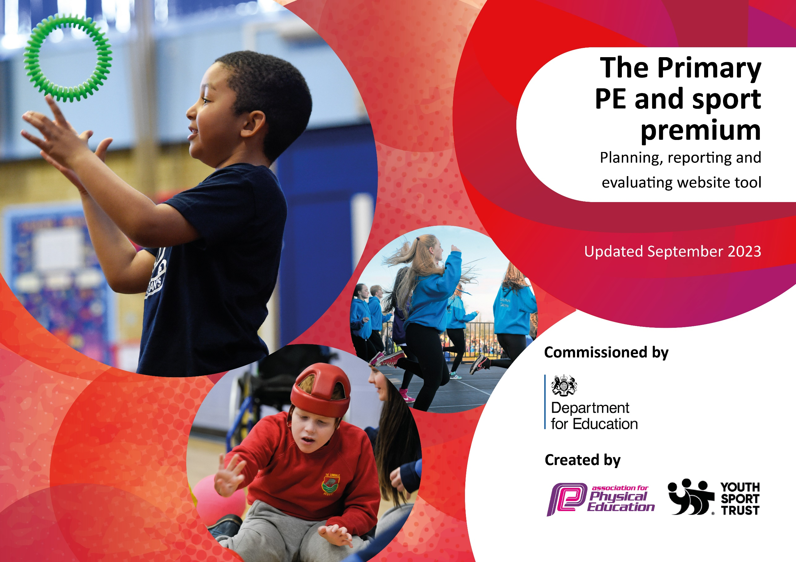

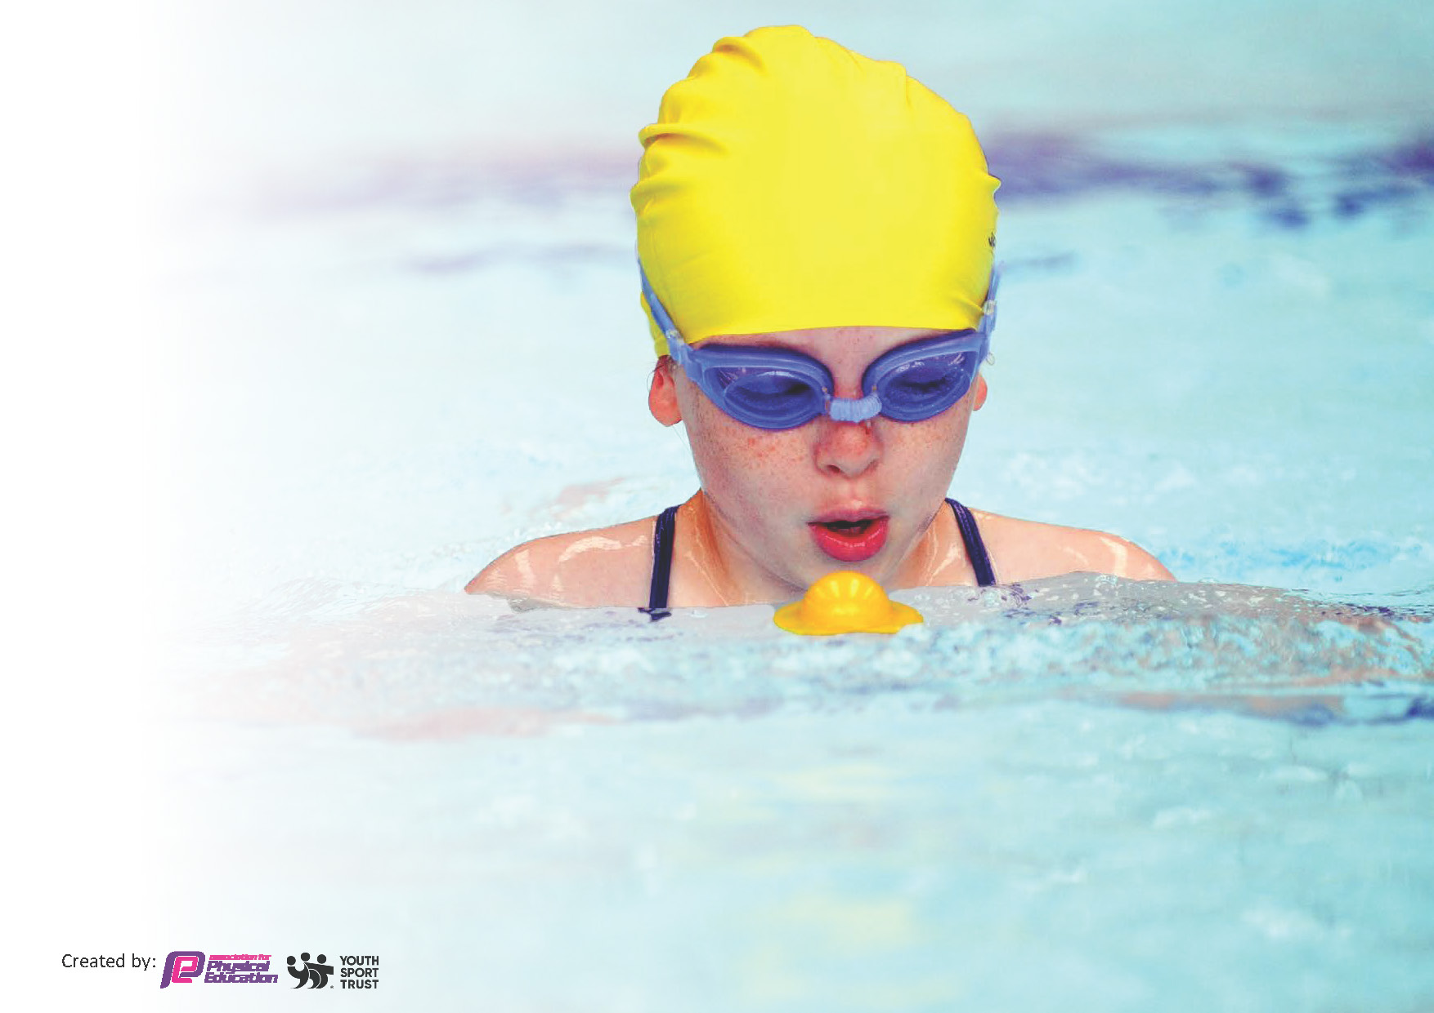
This template can be used for multiple purposes:
by:
- It enables schools to effectively plan their use of the Primary PE and sport premium
- It helps schools to meet the requirements (as set out in guidance) to publish information on their Primary PE and sport premium
- It will be an effective document to support Ofsted inspections enabling schools to evidence progress in Physical Education (PE) and evidence swimming attainment, which forms part of the PE National Curriculum. We would recommend schools consider
the Intent, Implementation and Impact of any spend, as examined within the Education Inspection Framework.

It is important that your grant is used effectively and based on school need.

Schools must use the funding to make additional and sustainable
improvements to the quality of the PE, School Sport and Physical Activity (PESSPA)
they offer. This means that you should use the Primary PE and sport premium to:

- Build capacity and capability within the school to ensure that improvements made now will benefit pupils joining the school in future years
- Develop or add to the PESSPA activities that your school already offers.

The Primary PE and sport premium should not be used to fund capital spend projects; the school’s core budget should fund these. Further detail on capital expenditure can be found in the updated Primary PE and sport premium guidance.

The Primary PE and sport premium guidance, outlines 5 key priorities that funding should be used towards. It is not

necessary that spending has to meet all the key priorities, you should select the priorities that you aim to use any funding towards.

Although completing this template is not a requirement for schools, schools are required to publish details of how they spend this funding. Schools must also outline what the impact this funding has had on pupils’ PE and sport participation and attainment and how any spending will be sustainable in the future. All funding must be spent by 31st July 2024.

The Department for Education has worked closely with the Association for Physical Education (afPE) and the Youth Sport Trust (YST) to develop this template and encourages schools to use it. This template is an effective way of meeting the reporting requirements of the Primary PE and sport premium.
Total amount allocated for 2023/24 | £19560
How much (if any) do you intend to carry over from this total fund into 2023/24? | £7951 (of which £2500 is allocated)
Total amount to be spent 2023/24 | £27511 Total spent £27522

Review of last year’s spend and key achievements (2022/2023)

We recommend you start by reflecting on the impact of current provision and reviewing your previous spend.

Activity/Action | Impact | Comments
Main achievements  On reflection from last years spend, the action that had the biggest impact was the CPD opportunity given to all teaching and support staff. All staff worked with PE Subject Leader for at least one term in gymnastics or dance. | All teaching and support staff have developed and improved their practice within gymnastics or dance. All staff have a better understanding of TGFKU. Teaching and learning for all pupils has been engaging with progression planned for. | An ongoing cycle of CPD for all staff within all areas of PE and Games will continue into academic year 2023/24.
The introduction of Yoga within the curriculum, as a after school club and a lunchtime club for our pupil premium pupils delivered by an outside provider as impacted on a high number of pupils mental health and well-being. | All pupils from EYFS to year 5 participate within the curriculum in 4 sessions over two terms. Pupils have a better understanding of calming techniques to support themselves when required. All teaching and support staff attending sessions, taking techniques and strategies back to the classroom. | Continuous programme of Yoga sessions and clubs booked for 2013/24.
Continued competitive opportunities for all pupils are actively researched and attended.  The enthesis on a healthy actively lifestyle remains a driving force within our school. | All pupils access competitive sport on a termly basis as will as higher levels of competition for a large number of our KS2 pupils. Active play, active learning and active after school clubs all contribute to our ethos of a lifelong active healthy lifestyle. | All opportunities will remain as will as research and engagement will continue to progress, offering more pupils active and competitive opportunities.

Key priorities and Planning
This planning template will allow schools to accurately plan their spending.

Action – what are you planning to do | Who does this action impact? | Key indicator to meet | Impacts and how sustainability will be achieved? | Cost linked to the action  Allocated 5000  Actual Spend £4682
Offer level 2 competitions to a large percentage of pupils across whole school  To use current School Games criteria to select pupils to attend events  Dover School Games Buy in competition package. To offer pupils higher level of competitive competition  To buy into Kent School Games competitive offer for more able pupils within PE and School sport.  To enter boys and girls football league and cup competitions  All pupils to participate in termly Intra-sport competitive competitions  All pupils across the whole school to participate in competitive sports day  Transport when required to be booked to enable pupils to attend competitive competitions  Supply costs to cover PE SL absence when attending fixtures and competitive events  Action – what are you planning to do  New Sport – experience day  Yo Street Football  Scorcha Skate  All pupils from EYFS to year 5 to participate in 4 sessions of yoga across 2 terms.  To keep of all-weather surface in good condition, ensuring all pupils can access physical active throughout the whole school year  Action – what are you planning to do  National Sports week – Protected Characteristics and Euro 2024  Action – what are you planning to do  All equipment required to deliver PE and Games within the curriculum.  Ensure continued level of engagement of all pupils.  Provide Active Play opportunities for all pupils to access regular daily physical activity contributing towards 60mins of daily physical activity  Research OPAL approach to physical active break and lunchtimes for all pupils  Additional focus swimming for pupils in year 4,5 and 6 to support 100% of year 6 pupils swimming 25m.  Extend existing Timber Trial to extend physical active for all pupils. To develop risk taking and own risk assessment for all pupils  Subscribe to Apple music to support all dance lessons for all pupils across academic year.  Action – what are you planning to do  SL to attend annual PE Conference to keep up to date with latest good practice within PE and School Sport.  To purchase AFPE membership to allow up to date information for all aspects within PESSPA.  SL to access current up to date information  SL to attend webinars to develop own CPD  Continue YST membership to ensure access for a range of resources for learning, CPD opportunities for staff. To access current PE and Sport information and guidelines  To continue to support and upskill both teaching and support staff across the whole school within PE and Games  To support confidence and subject knowledge for all teaching and support staff.  To supporting teaching staff to structure and deliver high quality teaching and learning for all pupils across dance, gym and games  CPD for teaching and support staff to access outdoor learning alongside termly sessions with outside provider.  All pupils will access and engage Forest school half a day on a termly basis  All pupils to access outdoor learning opportunities developing a greater understanding of the world around us.  CPD for all teaching staff to support children’s learning in gymnastics- forward/backward rolls | PE SL  Pupils  Support staff  Who does this action impact?  PE SL  HoS  SLT  All teaching and support staff  All pupils  PE SL  HoS  All teaching staff  Pupils  PE SL  Business manager  Who does this action impact?  PE SL  HoS  AHoS  All teaching/support staff  Outside providers  Who does this action impact?  PE SL  All support staff  Pupils  PE SL  HoS  Support staff  Pupils  PE SL  Business manager  Pupils  HoS  PE SL  Business manager  Outside company  PE SL  Business manager  Who does this action impact?  PE SL  Business manager  All teaching/support staff  Pupils  PE SL  New PE SL  HoS  Business manger  PE SL  Business manager  PE SL  Business manager  AHoS  AHoS  PE SL  Pupils  All teaching and support staff  PE SL  HoS  All teaching staff  Outside Gymnastic coach | KI5. Increased participation in competitive sport  Key indicator to meet  KI 4 Broader experience of a range of sports and activities offered to all pupils.  KI 4 Broader experience of a range of sports and activities offered to all pupils.  KI 4 Broader experience of a range of sports and activities offered to all pupils  Key indicator to meet  KI3 The profile of PE and sport is raised across the school as a tool for whole school improvement  Key indicator to meet  KI2 Engagement of all pupils in regular physical activity  KI2 Engagement of all pupils in regular physical activity  KI2 Engagement of all pupils in regular physical activity  KI2 Engagement of all pupils in regular physical activity  KI2 Engagement of all pupils in regular physical activity  Key indicator to meet  KI1 Increased confidence, knowledge and skills of all staff in teaching PE and sport  KI1 Increased confidence, knowledge and skills of all staff in teaching PE and sport  KI1 Increased confidence, knowledge and skills of all staff in teaching PE and sport  KI1 Increased confidence, knowledge and skills of all staff in teaching PE and sport  KI1 Increased confidence, knowledge and skills of all staff in teaching PE and sport  KI1 Increased confidence, knowledge and skills of all staff in teaching PE and sport | All pupils have experienced competitive sport on a termly basis through participating in year group intra-sport competitions.  A high number of pupils from KS2 will participate in competitive competitions at a level linked to their confidence and sporting ability. A high number of pupils will compete in a variety of different sporting events including inclusive, intra, inter and county level competitions.  Impacts and how sustainability will be achieved?  All pupils have experienced and engaged in two new sporting experience. These supported the confidence and resilience of all pupils to step outside of comfort zone.  All pupils from EYFS to year 5 have participated in yoga sessions. Developing calming and relaxation techniques to support mental health and well being. Pupils have developed strategies to use when required.  All pupils able to access outdoor learning and be physically active throughout the whole school year. All pupils are able to enhance performance when competing on sport surface.  Impacts and how sustainability will be achieved?  All pupils experienced competitive sport through a year group Girls and Boys Euros football tournament. Respect, sportsmanship and teamwork were recognized alongside the competitive element. All pupils reflected on our Diverse community exploring Protected Characteristics, Our focus was We have more in common than that which divides us.  Impacts and how sustainability will be achieved?  All pupils have access to 2hrs of high-quality Teaching and Learning on a weekly basis  All pupils are physically active for 45mins at lunchtime on a daily basis. This contributes towards 60 active mins daily on 3 days a week. Pupils are physically active for 105 mins 2 days a week through curriculum PE and Games and the OPAL programme. Pupils have a better understanding of their right to play – making informed risks, developing stamina, resilience and confidence within themselves.  8 out of 15 pupils completed their 25m swimming certificate through attending additional focus lessons.  Following pupil survey additional climbing and swinging elements will be offered. This will support improved upper body strength and core muscle.  This supports all pupils dance learning through allowing access to a wide range of music. Allowing different genres of dance to be explored and developed. Pupils experienced different cultures and movement patterns.  Impacts and how sustainability will be achieved?  SL attended a range of different workshops – supporting pupils with mental health and well being. Developing 60 mins of physical activity daily.  Access to all latest guidelines and support. SL engages in a range of webinars. PE and Sport Funding updates.  Access to all latest guidelines and support. SL engages in a range of webinars. PE and Sport Funding updates.  Following last academic years CPD offer for all staff in dance and gymnastics, a new reflective schedule will be put into place for next academic year. SL always available to support all teaching staff through discussions and emails.  All teaching staff attend termly forest school sessions to increase confidence and knowledge to deliver forest school activities.  All teaching staff attended CPD training from outside provider in progression in rolling within gymnastics. Ways to support and hold pupils as they experience forward and backward roles. | Estimated £4000  DSG 350  Kent swimming gala 55  KSG -Sportshall Athletics 125  Football league 53  Sportsday Medals 31  Sporthall Athletics x2 and London football Transport 660  Football shirts 137  Overtime 1484  TA overtime 432.00  Supply 125S  Respect lines 100  Cost linked to the action  Allocated 5000  Actual Spend £4310  Yo Street £1100  Sorcha skate £700  1920  590  Cost linked to the action  Allocated 4000  Actual Spend £13  13  Cost linked to the action  Allocated 6000  Actual Spend !2902  Estimated  1500  1458  Estimated  2000  6000  1953  Estimated  £871  2500  120  Cost linked to the action  Allocated 7500  Actual Spend £5615  295  190  240  Estimated  £1000  4860  30

Key achievements 2023-2024
This template will be completed at the end of the academic year and will showcase the key achievements schools have made with their Primary PE and sport premium spending.

Activity/Action | Impact | Comments
Engaging in OPAL programme | All pupils are physically active for 45mins at lunchtime. All pupils are meeting 60 active mins daily. All pupils have access to the right to play. The impact of physical active is helping support all pupil’s mental health and well-being. Pupils return to the classroom ready to engage in learning. | Increased risk benefit assessment by all pupils. Pupils stamina to remain active for longer periods of time. Increased confidence and resilience to try new experiences. To have a better understanding of their right to play.
Pupil engagement in intra and inter sport competitive situations. | Development of respect, teamwork and sportsmanship. A better understanding that sport is fun and enjoyable. All pupils experience a variety of team games, taking on different roles required within sport. | Pupils have accessed and variety of different levels of competition, participation festivals as well as competitive opportunities at a range of different sports. Leadership opportunities for all pupils are accessed through our termly intra-sport competitions.

Swimming Data
Meeting National Curriculum requirements for swimming and water safety.
Priority should always be given to ensuring that pupils can perform safe self-rescue even if they do not fully meet the first two requirements of the National Curriculum programme of study

Question | Stats: | Further context  Relative to local challenges
What percentage of your current Year 6 cohort can swim competently, confidently and proficiently over a distance of at least 25 metres? | 85% | All pupils attend swimming sessions in year 4. Pupils who do not meet the national curriculum aim are offered additional swimming sessions using sport funding money, with the aim to achieve 25m by the end of year 6.
What percentage of your current Year 6 cohort can use a range of strokes effectively [for example, front crawl, backstroke, and breaststroke]? | 85% | All pupils attend swimming sessions in year 4. Pupils who do not meet the national curriculum of performing a range of strokes are offered additional swimming sessions using sport funding money, with the aim to achieve a range of strokes by the end of year 6

What percentage of your current Year 6 cohort are able to perform safe self-rescue in different water-based situations? | 85% | All pupils attend swimming sessions in year 4. Pupils who do not meet the national curriculum aim are offered additional swimming sessions using sport funding money, with the aim to achieve self-rescue by the end of year 6
If your schools swimming data is below national expectation, you can choose to use the Primary PE and sport premium to provide additional top-up sessions for those pupils that did not meet National Curriculum  requirements after the completion of core lessons. Have you done this? | Yes | Please see data in plan above.
Have you provided CPD to improve the knowledge and confidence of staff to be able to teach swimming and water safety? | No | We use an experienced outside provider to deliver our swimming lessons to all pupils attending.

Signed off by:

Head Teacher: | (Name)
Subject Leader or the individual responsible for the Primary PE and sport premium: | (Name and Job Title)
Governor: | (Name and Role)
Date:

