**Top tips for supporting language through books and stories**

[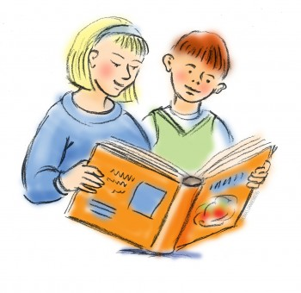](http://www.google.co.uk/url?sa=i&rct=j&q=&esrc=s&source=images&cd=&cad=rja&uact=8&ved=0ahUKEwi9v-a1hOfQAhVBPRQKHfVuDRsQjRwIBw&url=http://www.easyfreeclipart.com/sharing-books-clipart.html&bvm=bv.141320020,d.ZGg&psig=AFQjCNGQT1ptHQN_yXxZBQKy-v-57Y9Qcg&ust=1481369999879446)

* **Reading to your child, as well as hearing your child read. Reading a book that is a higher level to the child’s reading ability**
  + **This helps your child to learn more complicated vocabulary and sentence structures in a supported way**
* **Encouraging the child to choose the book** 
  + **This will mean they are more likely to be interested in the book and learn more from it**
* **Asking your child questions about the story or text** 
  + **This will support them to actively listen to the story, think about what they are reading and support their comprehension**
* **Looking out for new or unfamiliar words and talking about what they mean, making links with words they already know / in the same family**
  + **This will help your child to widen their vocabulary**
* **Use real objects and acting out whilst reading e.g. Story Sacks**
  + **This will help your child understand more of the story, bring it to life and make it more interesting**