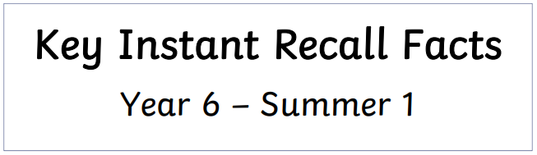****

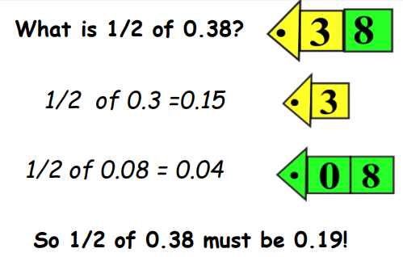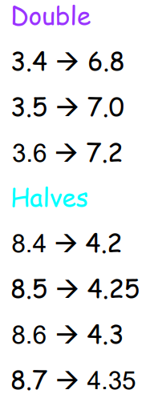

Children should mentally be able to calculate halves and doubles of 2-digit decimals by partitioning (splitting) the number into its place value parts.

See example below:

**Find half of 7.2**

**Half of 7 = 3.5**

**Half of 0.2 = 0.1**

**3.5 + 0.1 = 3.6**

**Key Vocabulary:**

What is **half** of 6.4?

What is **double** 2.7?

What is 3.2 **multiplied by 2**?

What is 4.5 **divided by 2**?

Practise online:

* Have a go at these timed questions: [Daily 10 - Mental Maths Challenge - Topmarks](https://www.topmarks.co.uk/maths-games/daily10)



Practical activity:

* Play number ping pong! Start off saying 'ping', child replies with 'pong'. Repeat and then change to numbers i.e. say 3.9' and they reply '7.8' (double 2-digit decimal) or say, '7.8' and they say '3.9' (half 2-digit decimal)



Make sure you also log in to TTRS and practise your times tables to 12 x 12.