

**English home learning**

**Year 6 -Summer 1**

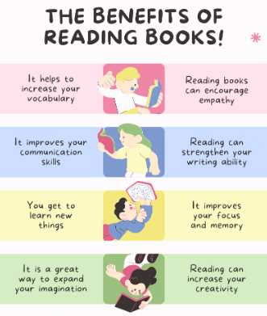

**Reading, Reading, Reading!**

Read for at least 10 – 15 minutes every day. You will

earn a dojo for each day you read at home,

Remember to complete your reading journal.

We like to hear about all your fantastic reading!

I can read and spell the following words.

|  |  |  |
| --- | --- | --- |
| Week 1 | Week 2 | Week 3 |
| **Words with the suffix ’-ably’**  changeably noticeably dependably comfortably reasonably adorably valuably believably considerably tolerably | **Words with the suffix ’-ible’**  reversible incredible possible horrible terrible responsible legible forcible sensible visible | **Adding the suffix ‘-ibly’ to create an adverb**  reversibly responsibly possibly horribly terribly visibly incredibly sensibly forcibly legibly |
| Week 4 | Week 5 |  |
| **Words ending in ‘-ent’ and ‘–ence’**  excellent excellence silent silence evident evidence convenient convenience different difference | **Words ending in ‘-er’, ‘-or’ and ‘-ar’**  computer superior customer soldier shoulder interior calendar popular particular radiator |  |

Practise online:

Log into your spelling shed account and play the games you have been set.