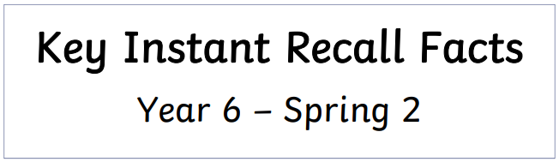****

**I know at least the first 5 cube numbers.**

By the end of this half term, children should know the following facts. The aim is for them to recall these facts instantly.

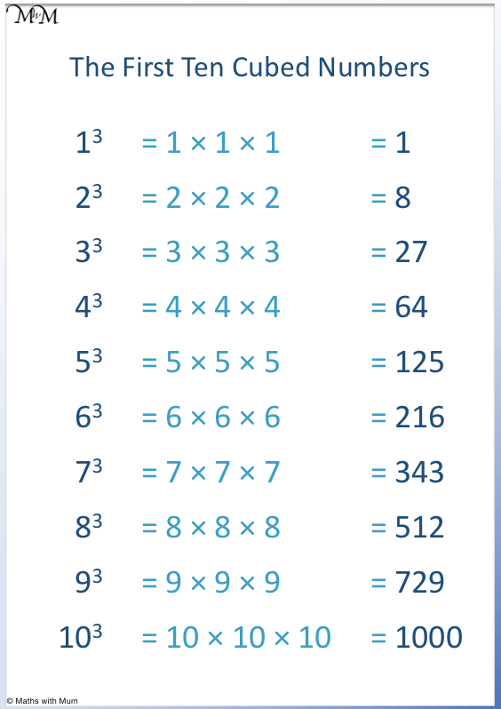

**Key Vocabulary:**

What is 3 **cubed**?

What is 4 **multiplied by itself then multiplied by itself again**?

What is 5 to **the power of three**?

Is 8 a **cube number**?

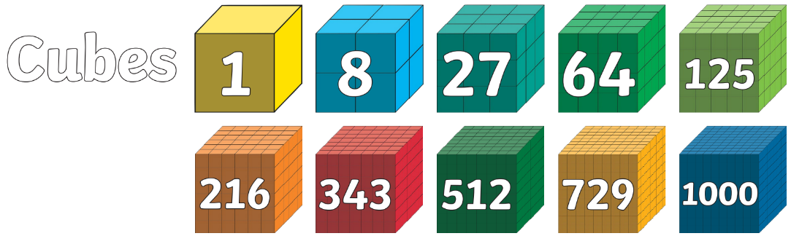

A **cube number**is the product of **three identical factors**. To find a cube number, multiply a whole number by **itself**and then **itself again**, for example, 3 x 3 x 3 = 27.

 Practise online:

* Log in to Math Shed and complete the assignments set.

Practical activity:

* Make a set of cards with the cube numbers and other two-digit and three-digit numbers. How quickly can your child identify the cube numbers?
* Use the sheet provided to make a spinner and play 4 in a row.



Make sure you also log in to TTRS and practise your times tables to 12 x 12.

|  |  |  |  |
| --- | --- | --- | --- |
| 1 | 27 | 8 | 64 |
| 125 | 64 | 1 | 27 |
| 64 | 8 | 125 | 5 |
| 27 | 1 | 64 | 8 |
| 8 | 27 | 64 | 1 |
| 125 | 8 | 27 | 64 |
| 1 | 125 | 8 | 27 |
| 64 | 125 | 1 | 125 |

**Cube Number Spinner**

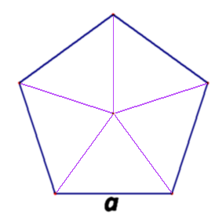

**1**3

**2**3

**3**3

**5**3

**4**3

**Game 1** - Spin the spinner to identify a Cube Number.  
Find a number on the grid matching the value of the Cube Number.  
Cover with a counter.   
The first to four in a line wins.

**Game 2** – Cover all the numbers on the grid with a counter.  
Spin the spinner to identify a cube number.  
Each player chooses to remove a counter to reveal a value..  
If a player’s value is **more** than the cube number on the spinner they keep their counter.  
If their value is **less** than that on the spinner they must put it back.

First to collect 5 counters wins