

**English home learning**

**Year 6 -Spring 2**

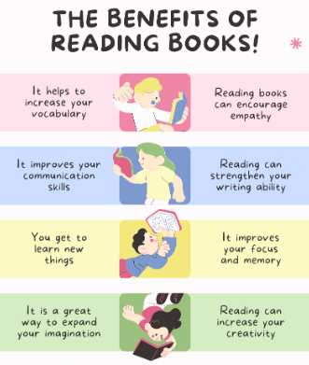

**Reading, Reading, Reading!**

Read for at least 10 – 15 minutes every day. You will

earn a dojo for each day you read at home,

Remember to complete your reading journal.

We like to hear about all your fantastic reading!

I can read and spell the following words.

|  |  |  |
| --- | --- | --- |
| Week 1 | Week 2 | Week 3 |
| **Words with a /f/ sound spelled ‘ph’**  graph pheasant phone photo physical alphabet dolphin elephant pamphlet sphere | **Words with origins in other countries and languages**  hoist easel restaurant pyjamas bungalow veranda ballet blizzard gymkhana origin | **Words with unstressed vowel sounds**  explanatory environment secretary jewellery poisonous company desperate definitely reference temperature |
| Week 4 | Week 5 | Week 6 |
| **Words ending with /shuhl/ spelled ‘cial’**  antisocial official superficial special artificial social racial crucial facial beneficial | **Words ending with /shuhl/ spelled ‘tial’**  influential martial spatial partial confidential essential substantial potential sequential torrential | **Words beginning with ‘acc’**  accompany accommodate access accuse accost accrue accuracy accomplish accumulate accentuate |

Practise online:

Log into your spelling shed account and play the games you have been set.