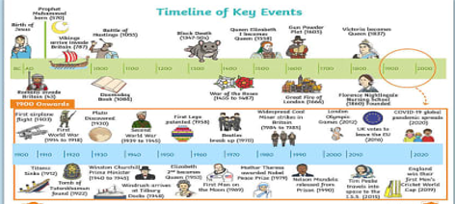**History Vocabulary Year 3**

|  |  |  |  |
| --- | --- | --- | --- |
| Chronological time consolidation |  | Citizen |  |
| BC / AD |  | Farming |  |
| Eras |  | Questions |  |
| Timeline |  | Opinion |  |
| Period |  | Experts |  |
| Millennium |  | Bar graph |  |
| Thousands of years |  | Compare |  |
| Prehistory/prehistoric |  | Initiate |  |
| Ancient |  | Theme |  |
| Hierarchy |  | Place |  |
| Invention |  | Investigate |  |
| Trade |  | Locality |  |
| Civilisation |  | Eye witness account |  |
| Wealth |  | Similarities/differences |  |
| Status |  | Archaeologists |  |
| Power |  | Excavation |  |
| Conflict |  | Perception |  |
| Religion |  | Think critically |  |
| Invade/invasion |  | Use judgement |  |
| Conquer |  | First hand evidence |  |
| Emperor |  | Second hand evidence |  |
| primary |  | Secondary |  |
| Source timeline |  | Museum |  |
| Exhibition |  | Interpret |  |
| Consequence |  |