**East** **Kent Virtual One Stop Shop**

**Does someone who is supposed to love you:**

**Make you feel afraid?**

**Make you feel ugly and useless?**

**Control you or your money?**

**Stop you seeing your friends and family?**

**Blame you, drugs, or drink for their behaviour?**

**Hurt you mentally, physically, or emotionally?**

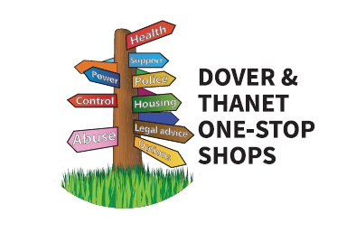

Anyone can access free and confidential specialist domestic abuse advise and information from a range of professionals

**From the 6th of April 2021**

* **Monday – Thursday mornings between 10:00 and 12:00**
* **Call: 07856856278**
* **Email:** [**EastKent1SS@gmail.com**](mailto:EastKent1SS@gmail.com)

An administrator will take your call or email and arrange for an appropriate professional to get back to you by 12:00 that day