
English home learning
Year 5 -Spring 1

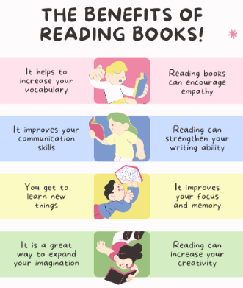
I can read and spell the following words.
Reading, Reading, Reading!
Read for at least 10 – 15 minutes every day. You will
earn a dojo for each day you read at home.
Remember to complete your reading journal at the
weekend. We like to hear about all your fantastic
reading!

Week 1 | Week 2 | Week 3
Words ending in ‘-able’, where the ‘e’ from the root word remains  changeable noticeable manageable agreeable knowledgeable replaceable microwaveable salvageable rechargeable irreplaceable | Words that are adverbs of time  afterwards immediately earlier eventually previously finally recently yesterday tomorrow whilst | Words ending in ‘–fer’  referring preferred transferring reference referee preference transference difference inference conferring
Week 4 | Week 5 | Week 6
Words with ‘silent’ first letters  knight wreckage writer knowledge knuckle wreath pterodactyl mnemonic wrestler knife | Words with ‘silent’ letters  doubt island lamb solemn thistle autumn build receipt ascend disciple | Challenge words  amateur ancient awkward criticise excellent foreign pronunciation symbol yacht equipment

Practise online:
Log into your spelling shed account and play the games you have been set.
You could practise common exception words using the link below and choose the words for your year group:
Little Bird Spelling || Practise spelling Common Exception Words

