

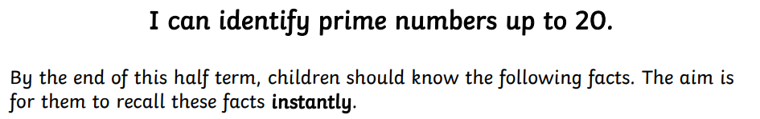

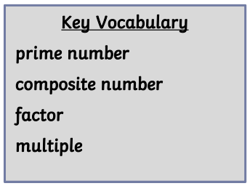
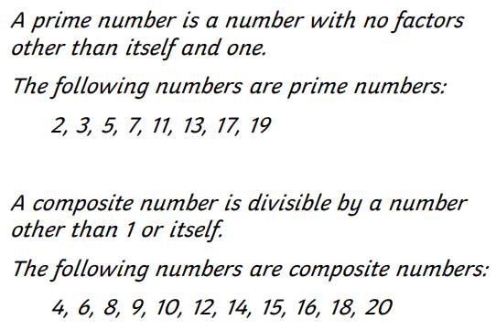

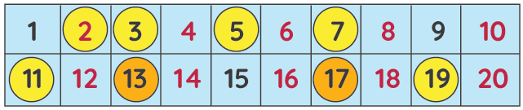


Practise online:
- Log in to TTRS to practise your multiplication and division facts to 12 x 12.

- Log in to Math Shed and complete the assignment set.
- Listen to or sing a Super Movers song:
KS2 Maths: Prime Numbers with Ben Shires - BBC Teach
Practical activities:
- Choose a number between 2 and 20. How many correct statements can your child make about this number using the vocabulary above?
- Make a set of cards for the numbers from 2 to 20. How quickly can your child sort these into prime and composite numbers? How many even prime numbers can they find? How many odd composite numbers?

