
English home learning
Year 5 -Spring 2

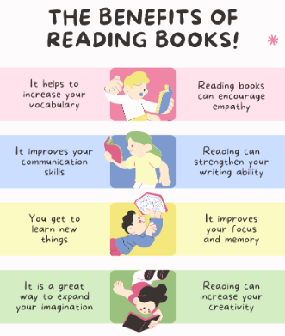
I can read and spell the following words.
Reading, Reading, Reading!
Read for at least 10 – 15 minutes every day. You will
earn a dojo for each day you read at home.
Remember to complete your reading journal at the
weekend. We like to hear about all your fantastic
reading!

Week 1 | Week 2 | Week 3
Homophones  advice advise device devise licence license practice practise prophecy prophesy | Words spelled with ’ie’ after c  ancient science species efficient deficient glacier scientists sufficient emergencies inefficient | Words where ‘ei’ makes an ‘ee’ sound  deceive conceive receive perceive receipt protein caffeine seize either neither
Week 4 | Week 5 | Week 6
Words where ‘ough’ makes an ‘or’ sound  bought fought thought ought sought nought brought wrought afterthought thoughtfulness | Words containing ’ough’  though although dough doughnut rough enough tough plough bough toughen | Adverbs of possibility and frequency  definitely possibly probably frequently infrequently occasionally rarely certainly obviously often

Practise online:
Log into your spelling shed account and play the games you have been set.
You could practise common exception words using the link below and choose the words for your year group:
Little Bird Spelling || Practise spelling Common Exception Words

