

Year 4 Group 1 – Summer 1
I know the multiplication and division facts for times tables up to 12 × 12

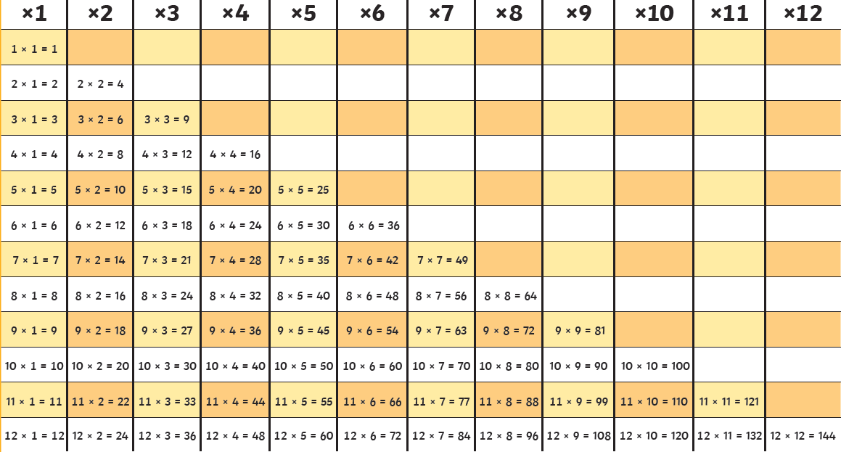



Practise online:
- Log in to TTRS and play Garage or do a Sound check

- Select any times table on the White Rose One Minute Maths app under multiplication or division
- Log in to Math Shed and select any times table.
- Sing along to the Super Movers times tables songs:
Super Movers: Times Tables Collection

Practical activity:
- Speed Challenge – Take a pack of playing cards. Turn over two cards and ask your child to multiply the numbers together (Ace = 1, Jack = 10, Queen = 11, King =12). How many questions can they answer correctly in 2 minutes? Practise regularly and see if they can beat their high score.


