

Year 4 Group 2 – Summer 1
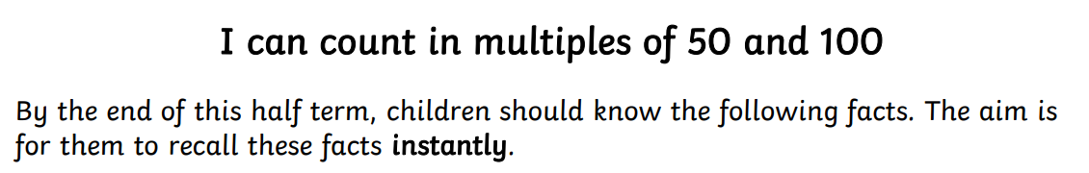
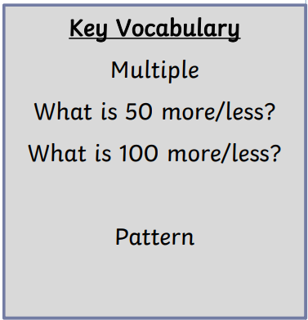
Counting in multiples of 50:
0, 50, 100, 150, 200, 250, 300, etc.

Counting in multiples of 100:
1,00, 2,00, 3,00, 4,00, 5,00, 6,00, 7,00, 8,00, 9,00, 1,000


Practise online:
- Log in to Math Shed and complete the assignments set.
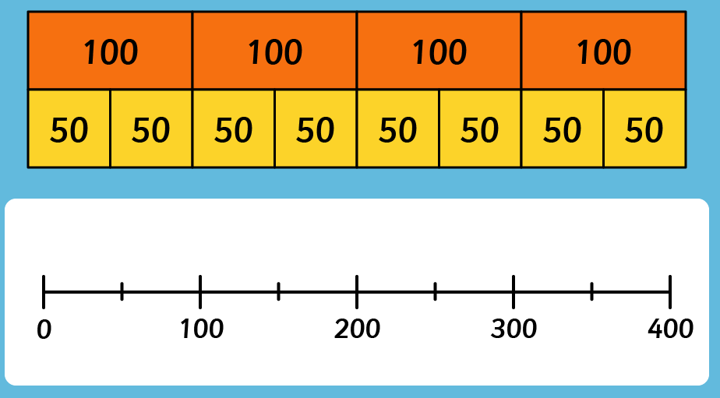

- Use money- 50p and £1 coins (to represent 100p). Use to count in 50s or 100s. How much will I have if I add one more 50p? How much will I have if I spend 100p (£1)?
Practical ideas:
- Can you spot the similarities between counting in 5s and 50s? Or 10s and 100s? Can you spot the link between counting in 50s and 100s?

Make sure you also log in to TTRS and practise your times tables.

