

Year 4 Group 3 – Summer 1
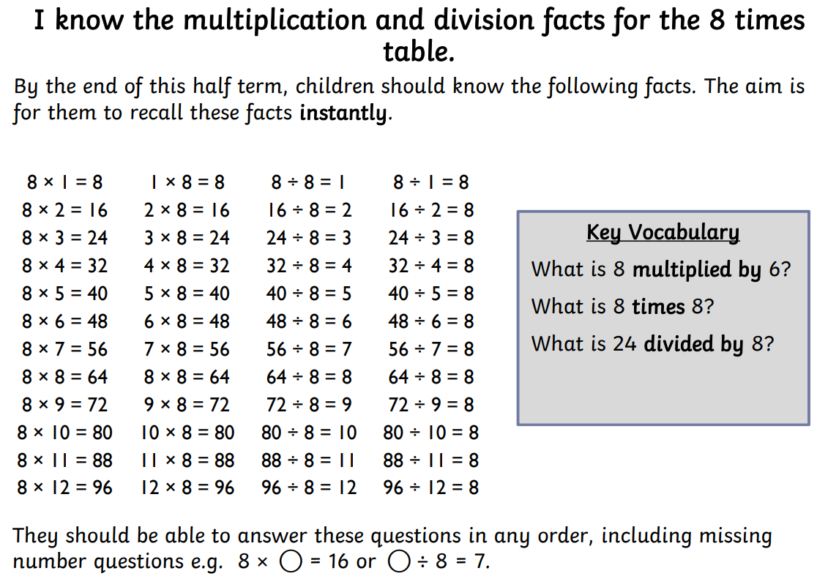




Practise online:
- White Rose One Minute Maths app - select ‘Multiplication’ then ‘Multiply by 8’ or ‘8 times table facts’. Select ‘Division’ then ‘8 times table’

- Log in to Math Shed - select ‘Times Tables’, click the ‘Single’ tab then select the 8 times table.
- Log in to TTRS and play Garage


