
English home learning
Year 4 – Group 1 Summer 1

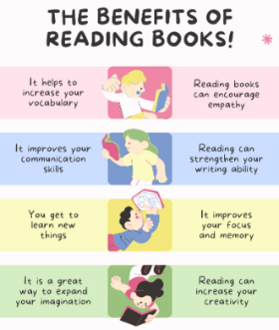
Reading, Reading, Reading!
Read for at least 10 – 15 minutes every day.
You may earn positive points for each time you read at home.

I can read and spell the following words.
Week 1 | Week 2 | Week 3
Words that are homophones  scene seen whose who’s affect effect here hear heel heal | Words spelled with ‘c’ before ‘i’ and ‘e’  circle century centaur circus princess voice medicine celebrate celery pencil | Words containing ‘sol’ and ‘real’  solar solution soluble insoluble dissolve real reality realistic unreal realisation
Week 4 | Week 5
Words containing ‘phon’ and ‘sign’  phone telephone phonics microphone phonograph sign signature assign designer signaller | Words with the prefixes ’super-’, ‘anti-’ and ‘auto  supermarket superman superstar superhuman antiseptic anticlockwise antisocial autobiography autograph automatic

Practise online:

Log into your spelling shed account and play the games you have been set.
You could practise common exception words using the link below:
Little Bird Spelling || Practise spelling Common Exception Words

