
English home learning
Year 4 Group 2 – Summer 1

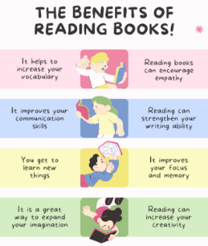
Reading, Reading, Reading!
Read for at least 10 – 15 minutes every day.
You may earn positive points for each time you read at home.

I can read and spell the following words.

Week 1 | Week 2 |  | Week 3
who  eye  love  push | pull  kind  mind  pass |  | laugh  sister  brother  mother
Week 4 |  | Week 5
good  food  jump  school |  | next  name  first  don’t


Practise online:

Log into your spelling shed account and play the games you have been set.
You could practise common exception words using the link below:
Little Bird Spelling || Practise spelling Common Exception Words

