
English home learning
Year 5 -Summer 1

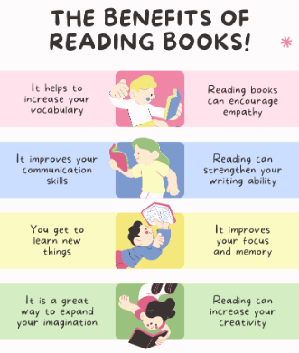
I can read and spell the following words.
Reading, Reading, Reading!
Read for at least 10 – 15 minutes every day. You will
earn a dojo for each day you read at home.
Remember to complete your reading journal at the
weekend. We like to hear about all your fantastic
reading!

Week 1 | Week 2 | Week 3
Words that are homophones  aisle isle  aloud allowed  altar alter  ascent assent  farther father | Words that are homophones  guessed guest  heard herd  morning mourning  past passed  bridal bridle | Words that are homophones or near homophones  cereal serial  complement compliment  principal principle  stationary stationery  wary weary
Week 4 | Week 5
Words that are homophones or near homophones  affect effect  precede proceed  draft draught  dessert desert  whose who’s | Challenge words  achieve apparent bargain bruise community mischievous muscle necessary vehicle system


Practise online:
Log into your spelling shed account and play the games you have been set.
You could practise common exception words using the link below and choose the words for your year group:
Little Bird Spelling || Practise spelling Common Exception Words

