
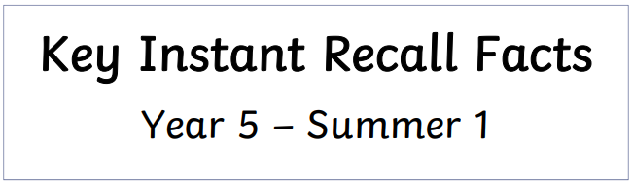
I know the decimal and percentage equivalent of common fractions.

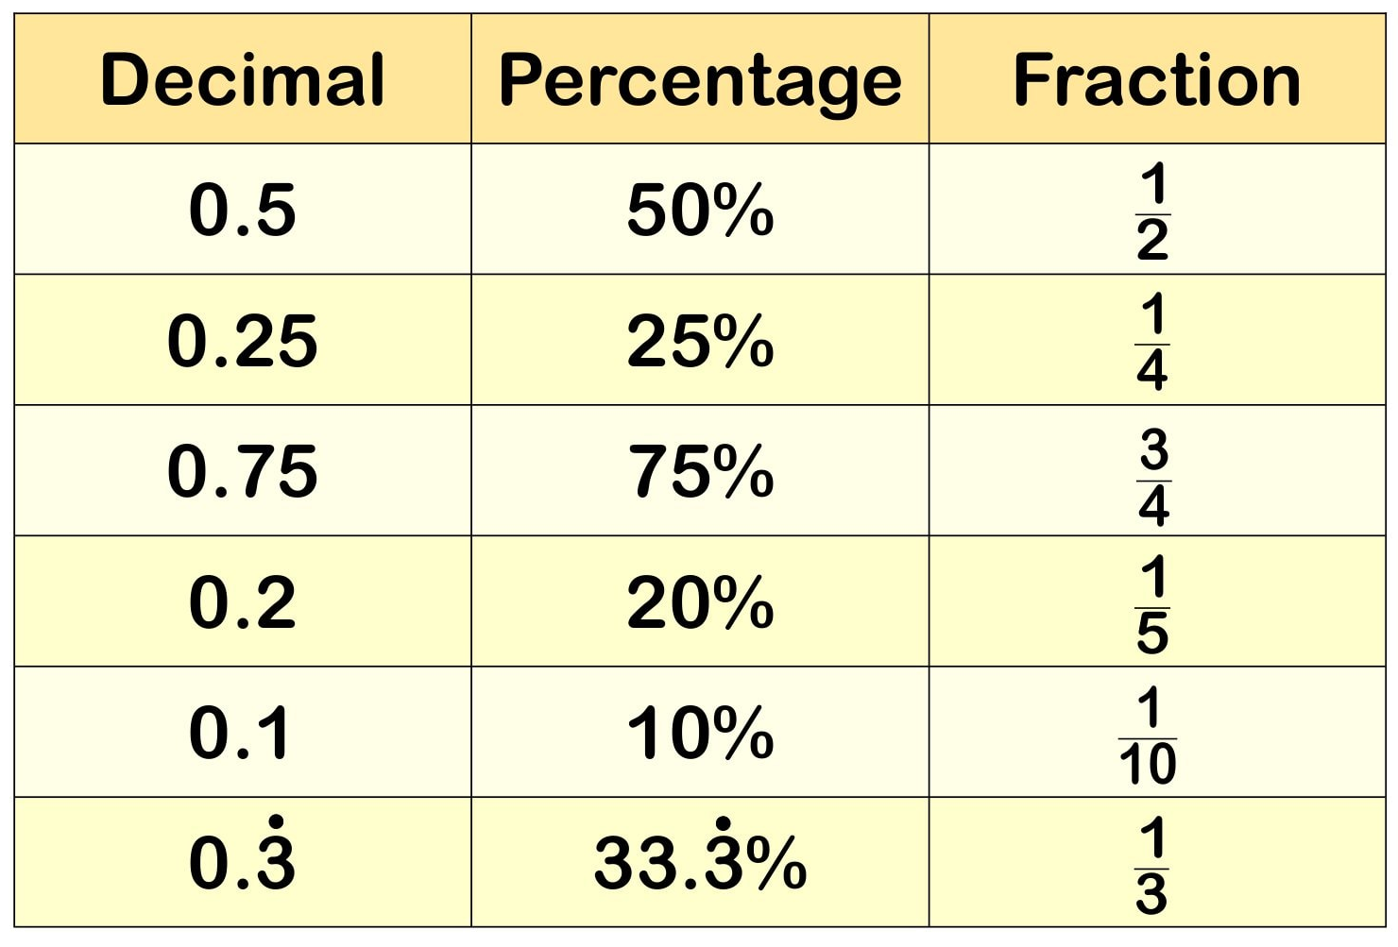
Key Vocabulary:
What is ¾ as a percentage?
Write 0.75 as a fraction.
Convert 20% to a fraction and a decimal.

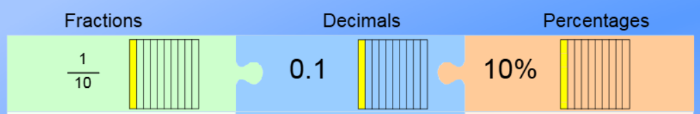



Practise online:
- Log in to TTRS to practise your multiplication and division facts to 12 x 12.
- Log in to Math Shed and complete the assignment set.
- Play this interactive game: Match Fractions Decimals and Percentages - Mathsframe
Practical activities:
- Play games - Make some cards with pairs of equivalent fractions and decimals. Use these to play the memory game or snap. Or make your own dominoes with fractions on one side and decimals on the other.

