
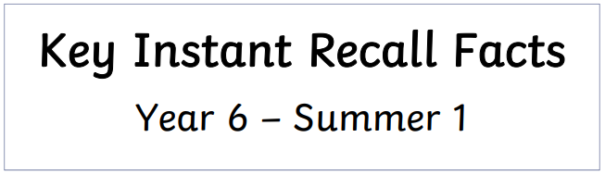
I know doubles and halves of two-digit decimals.
By the end of this half term, children should know how to calculate these facts rapidly.

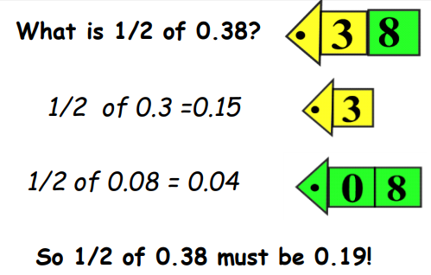
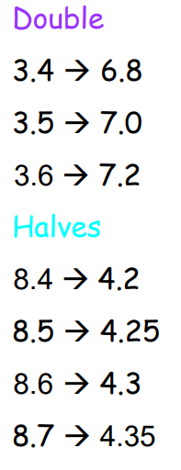
Children should mentally be able to calculate halves and doubles of 2-digit decimals by partitioning (splitting) the number into its place value parts.
See example below:
Find half of 7.2
Half of 7 = 3.5
Half of 0.2 = 0.1
3.5 + 0.1 = 3.6
Key Vocabulary:
What is half of 6.4?
What is double 2.7?
What is 3.2 multiplied by 2?
What is 4.5 divided by 2?

Practise online:
- Have a go at these timed questions: Daily 10 - Mental Maths Challenge - Topmarks

Practical activity:
- Play number ping pong! Start off saying 'ping', child replies with 'pong'. Repeat and then change to numbers i.e. say 3.9' and they reply '7.8' (double 2-digit decimal) or say, '7.8' and they say '3.9' (half 2-digit decimal)



Make sure you also log in to TTRS and practise your times tables to 12 x 12.

