
English home learning
Year 6 -Summer 1

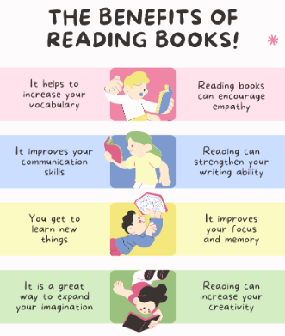
Reading, Reading, Reading!
Read for at least 10 – 15 minutes every day. You will
earn a dojo for each day you read at home,
Remember to complete your reading journal.
We like to hear about all your fantastic reading!

I can read and spell the following words.
Week 1 | Week 2 | Week 3
Words with the suffix ’-ably’  changeably noticeably dependably comfortably reasonably adorably valuably believably considerably tolerably | Words with the suffix ’-ible’  reversible incredible possible horrible terrible responsible legible forcible sensible visible | Adding the suffix ‘-ibly’ to create an adverb  reversibly responsibly possibly horribly terribly visibly incredibly sensibly forcibly legibly
Week 4 | Week 5
Words ending in ‘-ent’ and ‘–ence’  excellent excellence silent silence evident evidence convenient convenience different difference | Words ending in ‘-er’, ‘-or’ and ‘-ar’  computer superior customer soldier shoulder interior calendar popular particular radiator


Practise online:

Log into your spelling shed account and play the games you have been set.

