
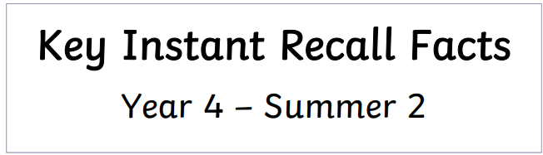
Year 4 Group 1 – Summer 2
I can multiply and divide 1 and 2-digit numbers by 10 and 100 (including decimals).

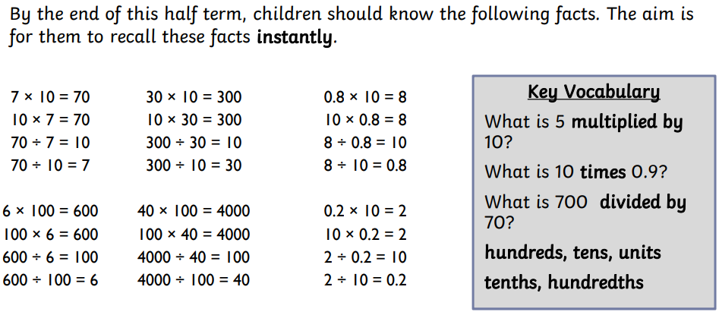

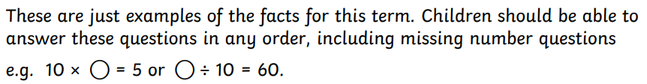


Practise online:

- Log in to TTRS and play Garage or do a Sound check.
- Log in to Math Shed and select the assignments set.
- Play Times of divide Bingo. Select ‘times and divide by 10 or 100 (decimals)
Times or Divide Bingo - 7-11 year olds - Topmarks
Practical activity:
Use the place value chart on the next page or create a larger one of your own. Use counters or digit cards to make a 1 or 2-digit number. Ask your child to multiply or divide the number by 10 or 100. Draw their attention to the prompts on the next page, e.g. ‘When we divide by 10, each digit moves one place value column to the right.’ Remind your child that the decimal point keeps its position, it does not move.


