

Year 4 Group 2 – Summer 2
I can find 10 more or less than a given number.
By the end of this half term, your child needs to be able to find 10 or 100 more or less with numbers that cross over the tens or hundreds. For example, 10 more or 10 less than 94:

94 + 10 = 104 576 + 100 = 676
94 – 10 = 84 576 – 100 = 476

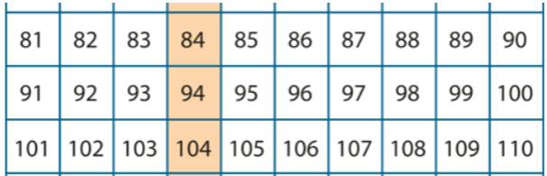
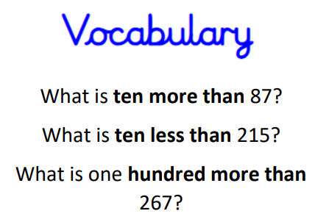

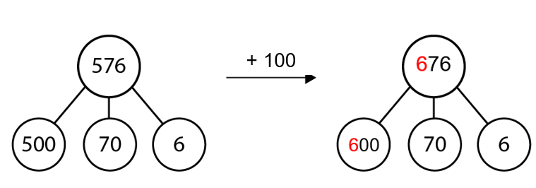
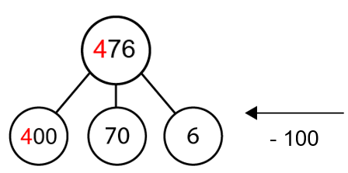

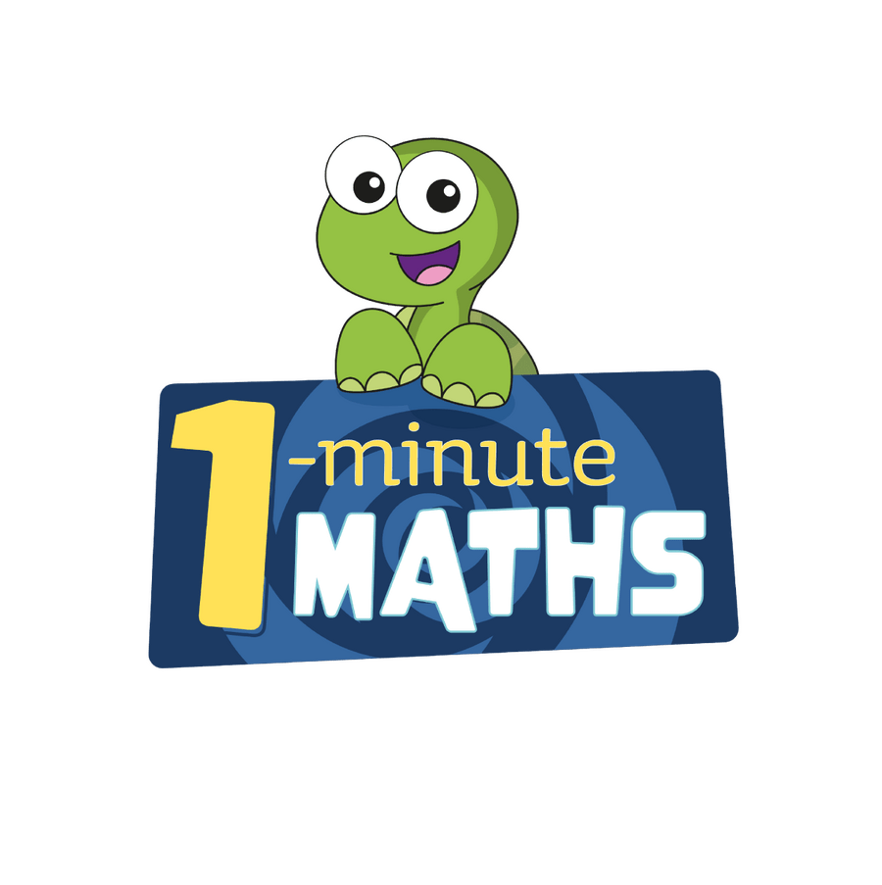
Practise online:


- Download the White Rose One Minute Maths app and select ‘Addition’ then ‘Add 10’ or ‘Subtraction’ and ‘Subtract 10’.
- Log in to Math Shed and complete the assignment set.
Practical game:
Roll a dice twice to make a two-digit number, three times to make a three-digit number. Can your child tell you what is 10 more or 10 less? What is 100 more or 100 less?


Make sure you also log in to TTRS and practise your times tables.

