

Year 4 Group 3 – Summer 2
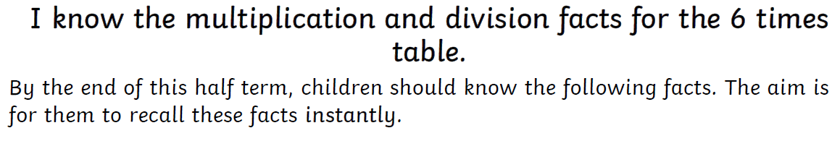

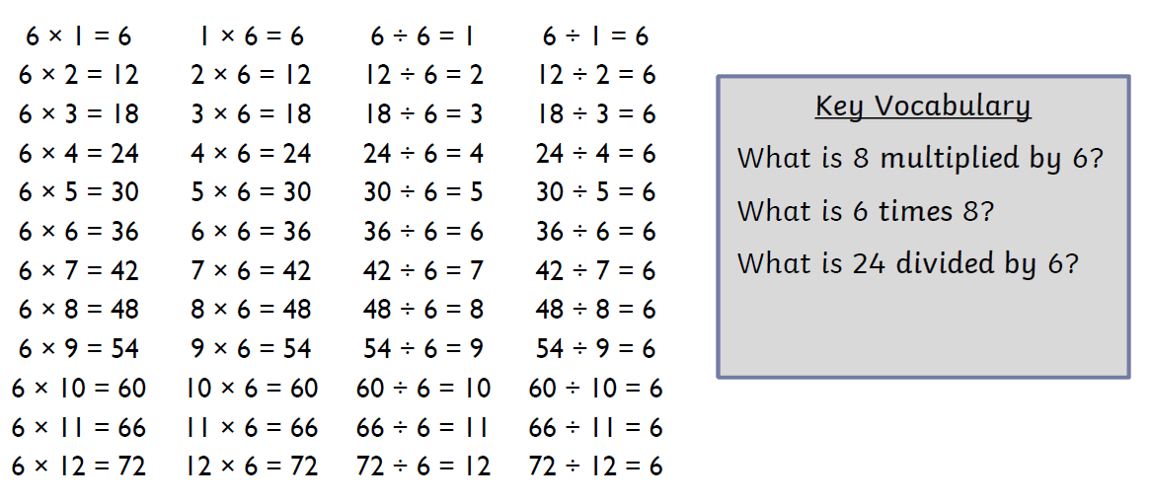

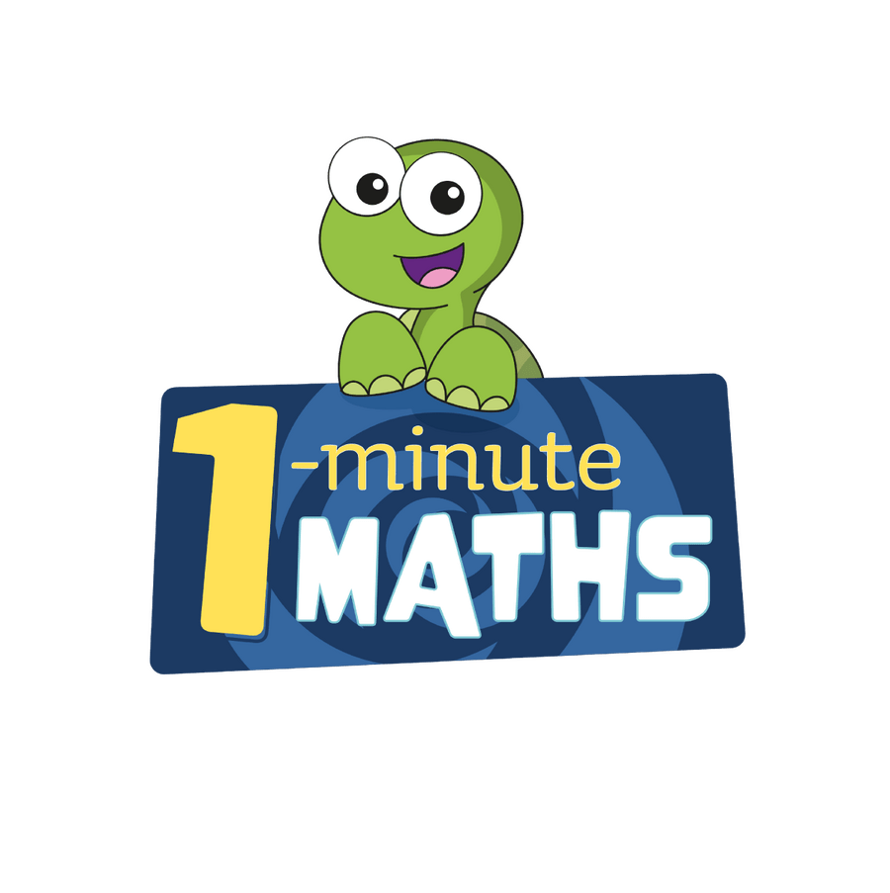

Practise online:
- Log in to TTRS and play Garage
- Download the White Rose One Minute Maths app and select the 6 times table

- Log in to Math Shed and select the 6 times table.
- Learn a times table song:
KS2 Maths: The 6 Times Table with Fred the Red - BBC Teach


