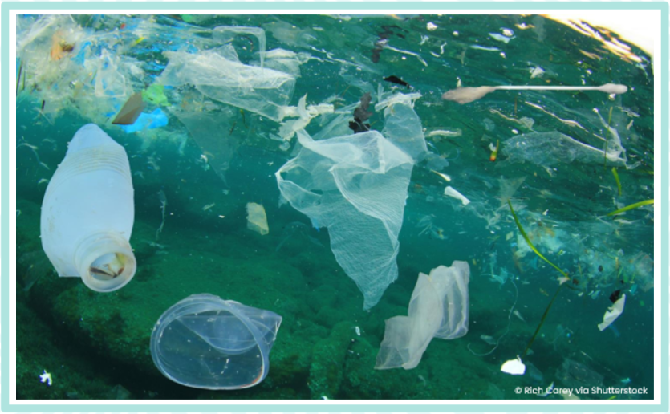  Look at the enlarged version of the picture above.  What plastic items can you see? What pollution do you think can’t be seen? | What is single-use plastic?  Why is it so harmful?  Keep a record of all single-use plastic that your family use in a week.  How could you present your findings? | 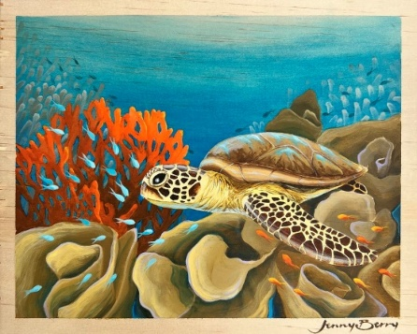  Study the artwork of Jenny Berry. Research an endangered marine animal. Create artwork that represents the animal in its natural habitat.
Watch the following clip:  Blue Planet II Plastic Pollution Awareness 2018  What can you find out about David Attenborough?  How has David Attenborough educated people about protecting the oceans? | Watch the following video:  Fight against plastic pollution | WWF  Research and create a fact file or leaflet with information about plastic pollution and how we can take action. | What are the different zones in the ocean?  What lives in each zone?  Create a diagram to show your findings.
Keep a diary of your family’s water use over a week.  How could you save water at home? | Visit a local beach.  What species of plants and animals can you find?  How could you record your findings? | 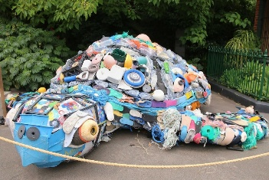  Use plastic waste at home to create a sculpture to raise awareness about the effects of plastic pollution on marine animals.
The home learning grid gives a variety of creative tasks for the children to choose from, which link to their topic for the term. We suggest that children choose one to complete, however should they wish to complete more, we recommend no more than three. These tasks are optional and should be chosen in addition to, not instead of, the English and Maths key learning tasks.
Home learning is due in by the last day of term.

