
English home learning
Year 4 Group 1-Summer 2

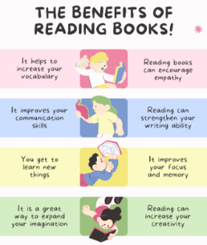
Reading, Reading, Reading!
Read for at least 10 – 15 minutes every day.
You may earn positive points for each day you read at home.

I can read and spell the following words.
Week 1 | Week 2 | Week 3
Words with the prefix ’bi-’bicycle, biplane, biped bicentennial, biannual bilingual, bicuspid, biceps binoculars, bisect | Words containing an apostrophe for possession  girls’, boys’, babies’ children’s, men’s, mice’s ladies’, cats’, women’s geese’s | Revision of spelling patterns  expression, musician reluctantly, group, scene circle, solar, supermarket
Week 4 | Week 5 | Week 6
Revision of spelling patterns  bicycle, except  incorrect, illegible, subject international, believe preparation | Revision of spelling patterns  coronation, wildly, bravely thoughtfully  brochure, famous  tension, penniless | Revision of spelling patterns  hideous different astronaut completion admission mathematician, gently, separate

Practise online:

Log into your spelling shed account and play the games you have been set.
You could practise common exception words using the link below:
Little Bird Spelling || Practise spelling Common Exception Words

