
English home learning
Year 4 Group 2 – Summer 2

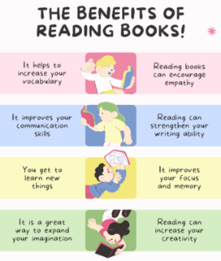
Reading, Reading, Reading!
Read for at least 10 – 15 minutes every day.
You may earn positive points for each time you read at home.

I can read and spell the following words.

Week 1 |  | Week 2 |  |  | Week 3
can’t  seen  week  night |  | light  more  red  orange |  |  | green  blue  black  white
Week 4 | Week 5 |  | Week 6
brown  pink  purple  grey | gold  silver  hundred  year |  | can’t  seen  week  night  light  more  hundred | red  orange green  blue  black  white  year |  | brown  pink  purple  grey  gold  silver


Practise online:

Log into your spelling shed account and play the games you have been set.
You could practise common exception words using the link below:
Little Bird Spelling || Practise spelling Common Exception Words

