
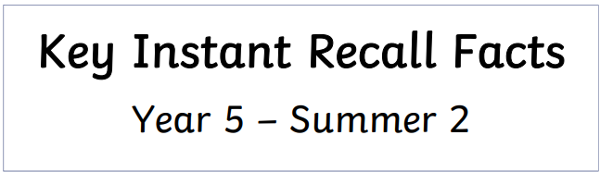
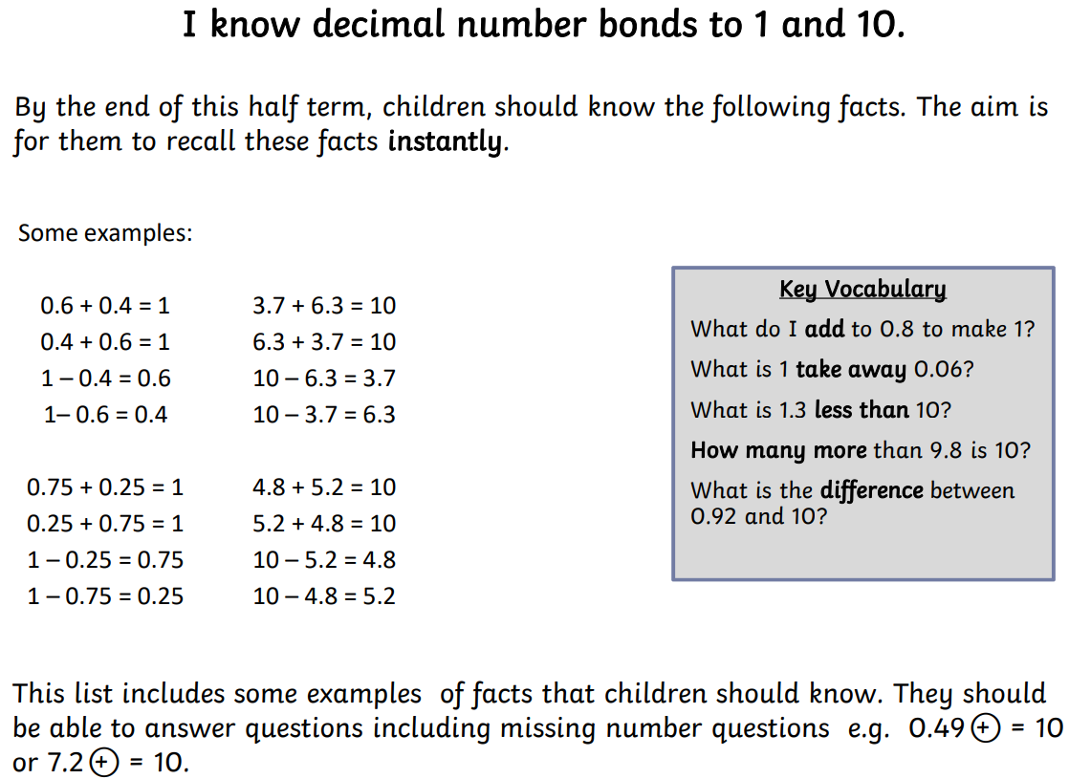


Practise online:
- Log in to Math Shed and complete the assignment set.
- Play ‘Hit the Button’. Select ‘Number Bonds’ then ‘Decimals: Make 1 (1dp)’ or ‘Decimals: Make 10 (1dp) Hit the Button - Quick fire maths practise for 6-11 year olds

Don’t forget to also log in to TTRS to practise your multiplication and division facts to 12 x 12.

Practical activities:
Make cards with decimal numbers. Give your child a decimal number card, e.g. 2.7 and ask them to find the decimal number that would make 10. 2. 7 + ___ = 10.
Encourage your child to explain their reasoning, e.g. I know that 0.7 + 0.3 = 1, so 2.7 + 0.3 = 3. Then 3 + 7 = 10. This means that 2.7 + 7.3 = 10



