
English home learning
Year 5 -Summer 2

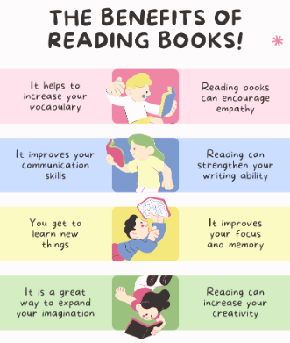
I can read and spell the following words.
Reading, Reading, Reading!
Read for at least 10 – 15 minutes every day. You will
earn a dojo for each day you read at home.
Remember to complete your reading journal at the
weekend. We like to hear about all your fantastic
reading!

Week 1 | Week 2 | Week 3
co-ordinate co-operate co-own co-author re-enter re-examine re-evaluate re-educate re-explain re-energise | bought though definitely accompany advice aisle guessed cereal | affect  achieve fictitious conscious constant elegance frequent  understandable
Week 4 | Week 5 | Week 6
comfortably controversy manageable earlier  probably conscience | transferring writer ascend awkward species receive thought dough | immediate sincere changeable afterwards referring knight doubt amateur ancient deceive

Practise online:
Log into your spelling shed account and play the games you have been set.
You could practise common exception words using the link below and choose the words for your year group:
Little Bird Spelling || Practise spelling Common Exception Words

