
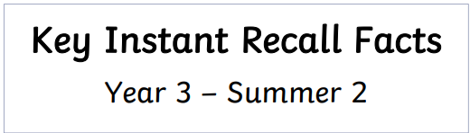
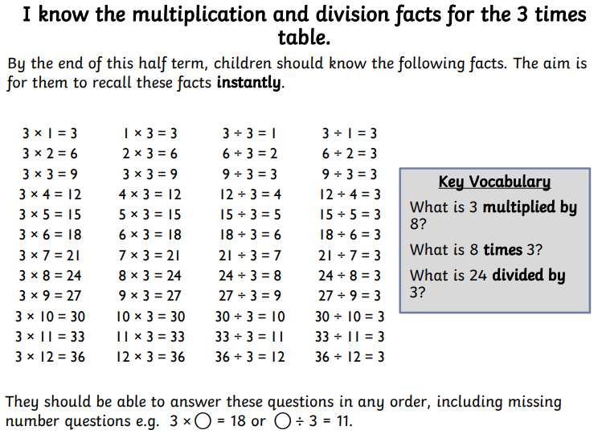

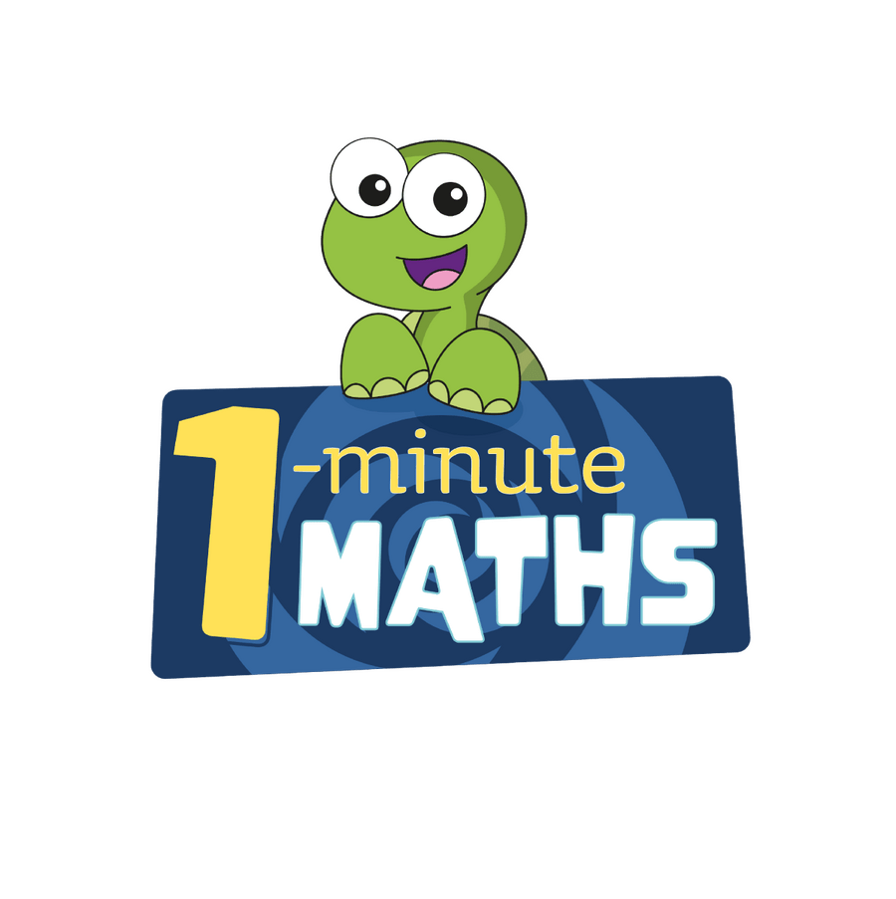


Practise online:
- White Rose One Minute Maths app - select ‘Multiplication’ then ‘Multiply by 3’ or ‘3 times table facts’. Select ‘Division’ then ‘3 times table’

- Log in to Math Shed - select ‘Times Tables’, click the ‘Single’ tab then select the 3 times table.
- Log in to TTRS and play Jamming. Select the 3 times table.

- Super Movers: sing along https://www.bbc.co.uk/teach/supermovers/articles/z6sw382
Practical activity:
Give your child a group of small objects such as counters, beads, or even dried beans (very cheap and they work well). Then call out a multiplication fact and ask your child to group the objects to model the fact.

