
English home learning
Year 3 -Summer 2

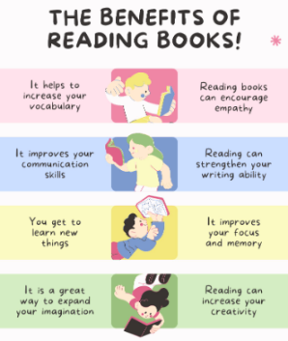
I can read and spell the following words.
Reading, Reading, Reading!
Read for at least 10 – 15 minutes every day.
You will earn a point for each day you read at home.

Week 1 | Week 2 | Week 3
Words that end in ‘sion’  division, invasion confusion, decision collision, television, erosion, vision, fusion | Revision of spelling patterns  exactly, bravely, pleasure, dislocate, island, decide,  disadvantage, survey, ordinary, promise | Revision of spelling patterns  freight, hourly, missed, scented, suppose, plaque,  grotesque, daily, descend, automatically
Week 4 | Week 5 | Week 6
Revision of spelling patterns  teacher, scheme, history, mention, bawl, crescent,  eighteen, regular, mane, disable | Revision of spelling patterns  disappear, specifically, reaction, committed, misunderstanding,  forbidden, capable, neighbour, personal, confusion | Challenge words  special, strange, difficult, important, length, perhaps,  position, pressure, question, purpose

Practise online:
Log into your spelling shed account and play the games you have been set.
You could practise common exception words using the link below:
Little Bird Spelling || Practise spelling Common Exception Words

