
English home learning
Year 4 Autumn 1 – Group 2

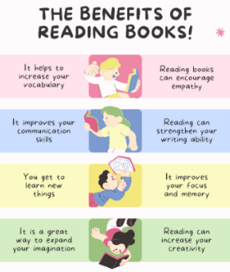
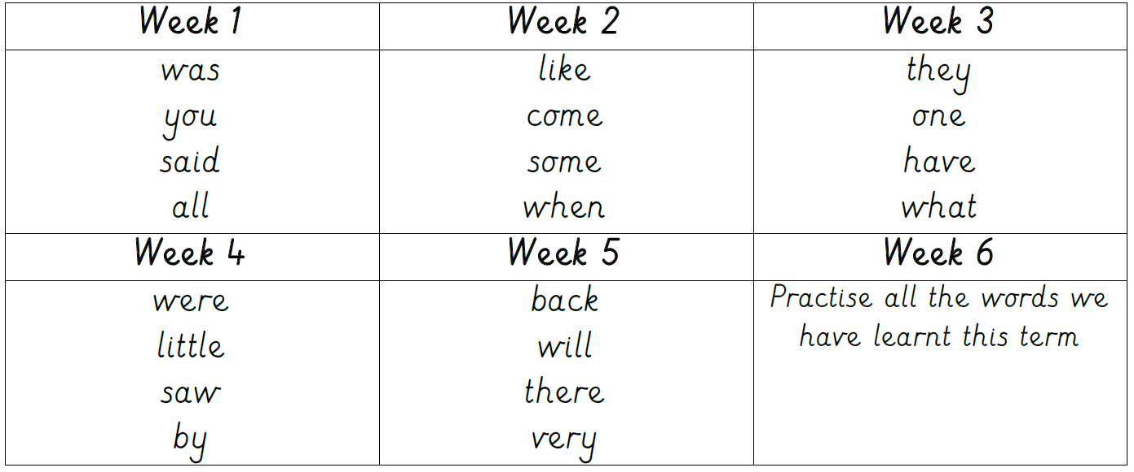
Reading, Reading, Reading!
Read for at least 10 – 15 minutes every day.

I can read and spell the following words.
Practise online:
You could practise common exception words using the link below:
Little Bird Spelling || Practise spelling Common Exception Words

