
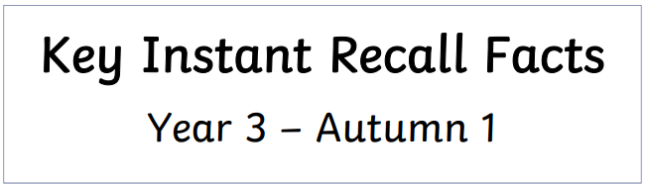
I know number bonds to 100
By the end of this half term, children should know the following facts. The aim is for them to recall these facts instantly.

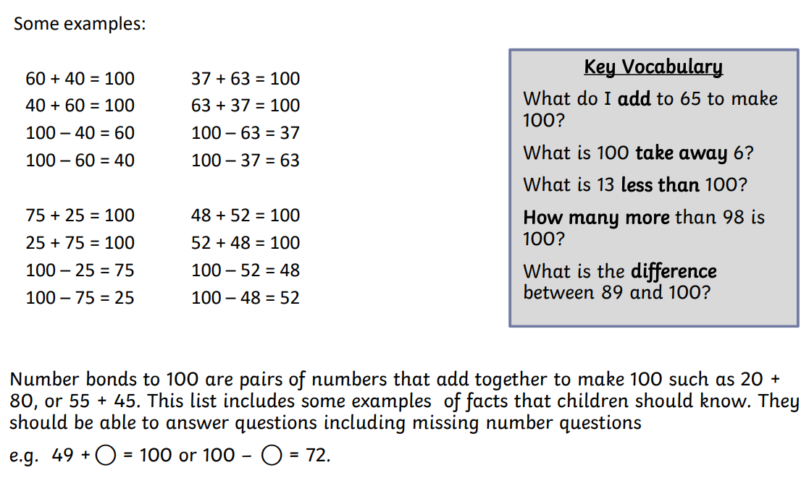

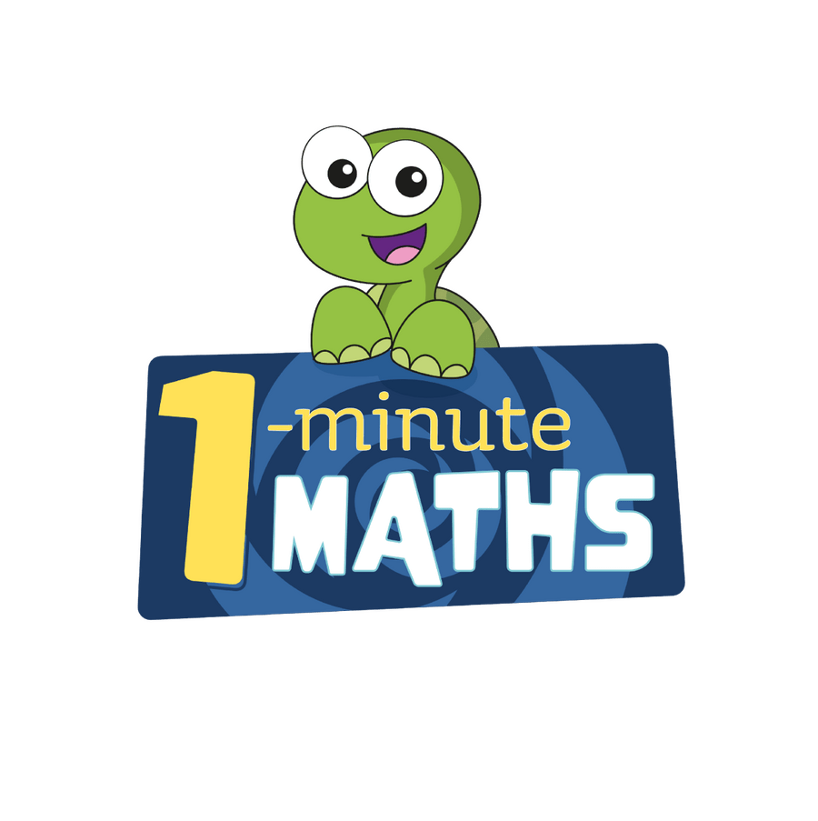

Practise online:
- Download the White Rose One Minute Maths app and select:
‘Addition’ then ‘Bonds to 100 (tens)’ or ‘Bonds to 100 (tens and ones)‘

- Log in to Math Shed and select ‘Number Bonds’ then ‘Bonds to 100’
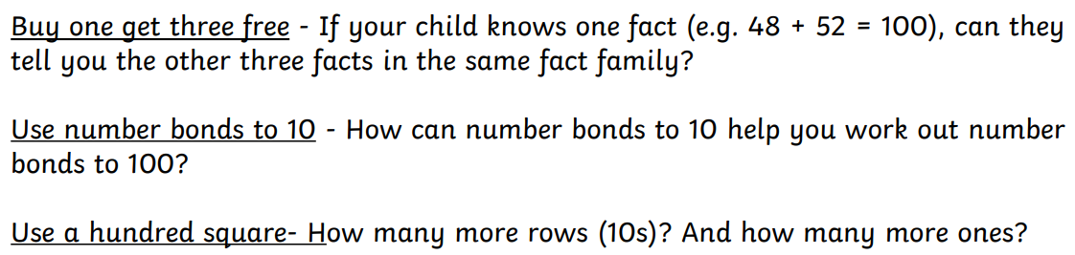


Make sure you also log in to TTRS and practise your times tables.

