

Year 4 – Autumn 1
Group 2
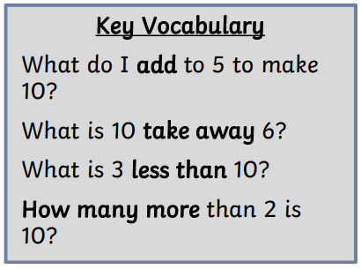
I know number bonds for each number to 10.

By the end of this half term, children should know the following facts. The aim is for them to recall these facts instantly.

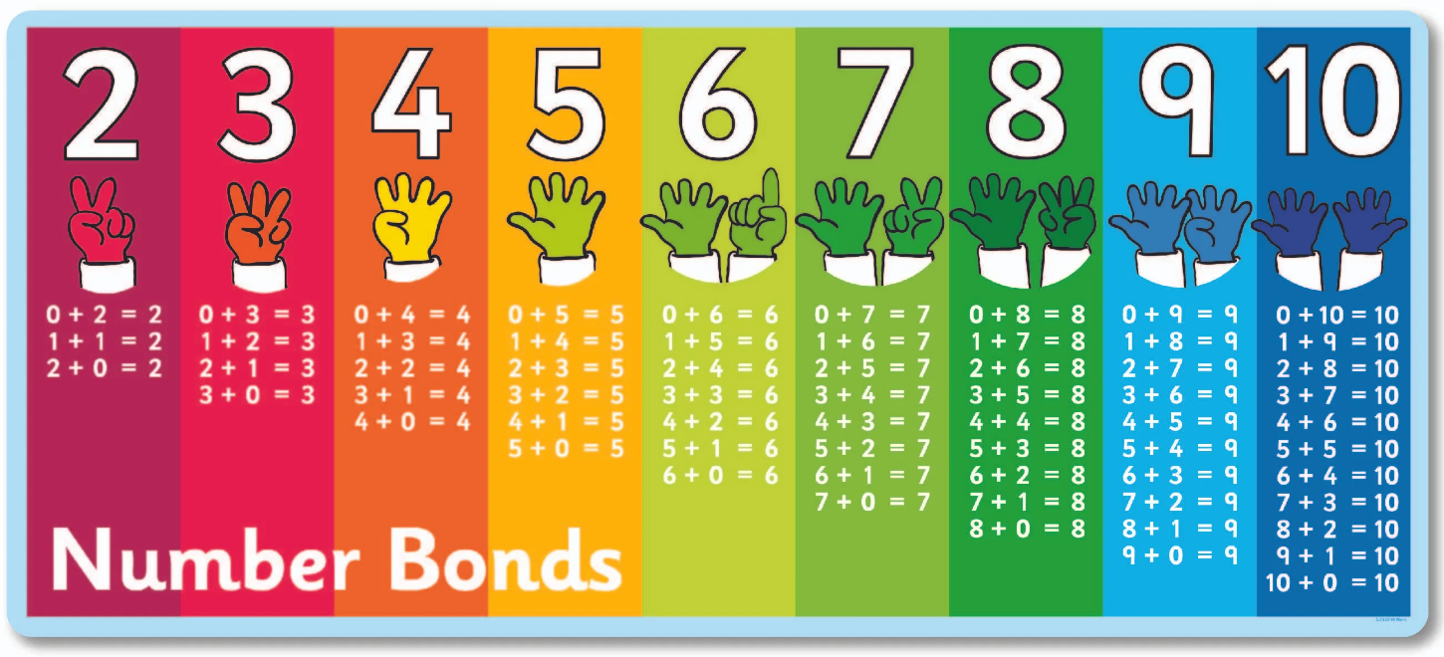

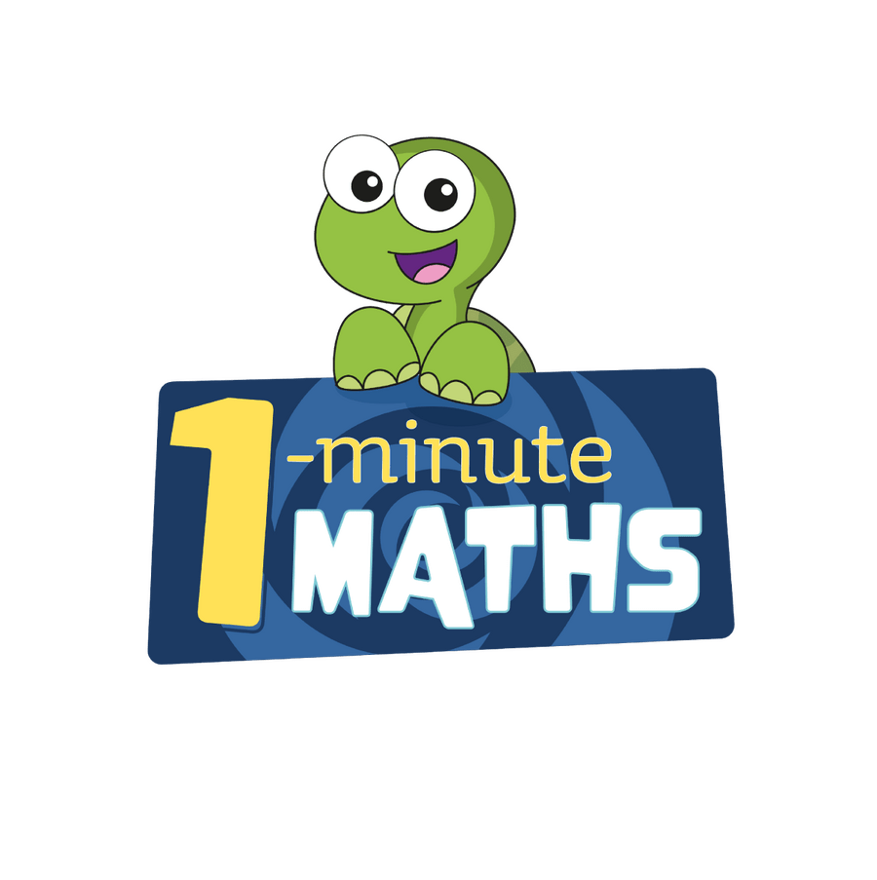

Practise online:
- White Rose One Minute Maths app - select ‘Addition’ then ‘Add within 10’ or ‘Bonds to 10’. Select ‘Subtraction’ then subtract from 10’ or ‘Subtract within 10’
Practical idea:
Pick a number, say 9. Use playing cards or a dice, can they work out how many more to make a 9?

6 + ? = 9 or 9 – 6 = ?



