

Year 4 – Autumn 1
Group 3
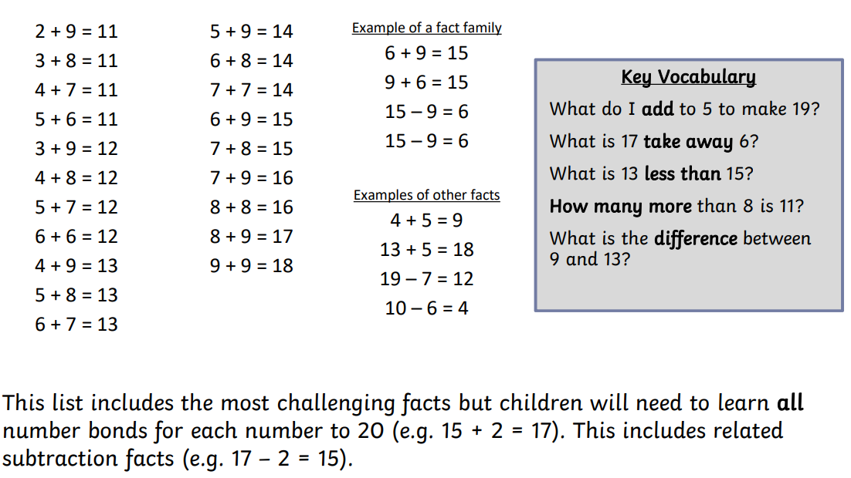
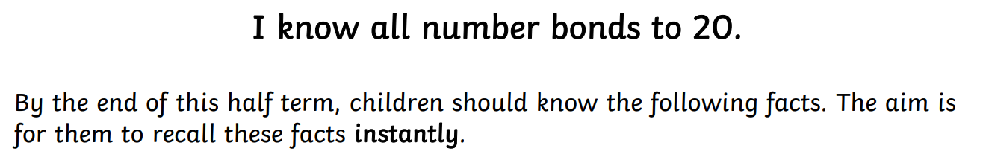


Practise online:
- Download the White Rose One Minute Maths app and select ‘Addition’ then ‘Magic Mix to 20’ or ‘Subtraction’ and ‘Magic Mix in 20’


