
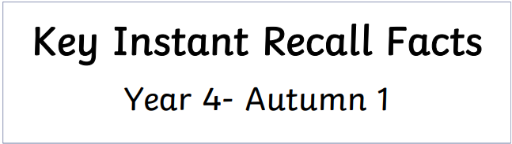
Year 4 – Autumn 1
Group 1
I can count in multiples of 1000 and 25
By the end of this half term, children should know the following facts. The aim is for them to recall these facts instantly.

Counting in multiples of 25:
0, 25, 50, 75, 100, 125, 150, 175, 200, 225, 250, 275, 300, etc.

Counting in multiples of 1,000:
1,000, 2,000, 3,000, 4,000, 5,000, 6,000, 7,000, 8,000, 9,000, 10,000,
Key vocabulary
What is the third multiple of 25?
How many groups of 25 equal 200?
How many thousands make 8,000?
Count back from 6,000 in steps of 1000.


Practise online:
- Log in to Math Shed and complete the assignment set.

Use what you already know – If your child knows how to count in multiples of 50, they can use this knowledge to count in multiples of 25 as half of 50 equals 25. E.g. 2 x 50 = 100 so 4 x 25 = 100
Target number - Chant multiples of 25 or 1,000 together. Start at different multiples and count forwards or backwards towards a target number, e.g. “Start at 500 and count back in steps of 25. Can you reach 200?”.


Make sure you also log in to TTRS and practise your times tables.

