

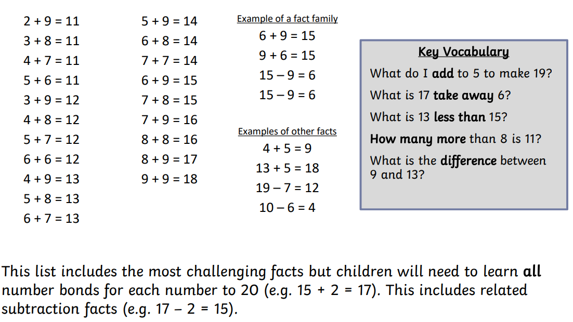
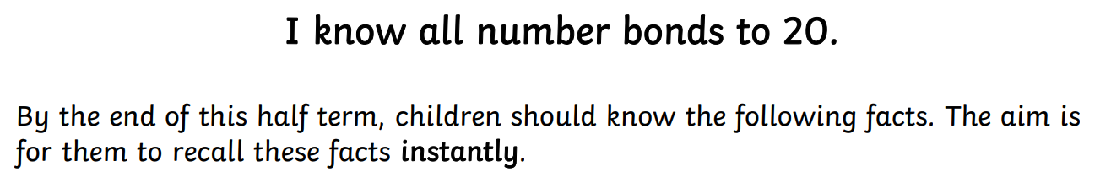


Practise online:

- Download the White Rose One Minute Maths app and select ‘Addition’ then ‘Magic Mix to 20’ or ‘Subtraction’ and ‘Magic Mix in 20’
- Log in to Math Shed and complete the assignment set. You can also select ‘Add and Subtract’ then ‘Within 20’.


